The following excerpts are from B. H. Roberts’s speeches at the Utah State Constitutional Convention in 1895. Roberts was Davis County’s Delegate at the convention and a Mormon leader, politician, and historian. At the Constitutional Convention, he was the key voice in opposing the inclusion of women’s suffrage in the state constitution. A few years later, he was denied a seat in the U.S. Congress because he was a polygamist.

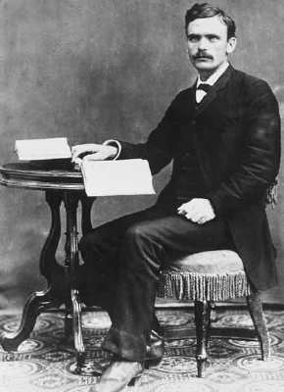
“Let me say that the influence of woman as it operates upon me never came from the rostrum [the stage], it never came from the pulpit...it never came from the lecturer's platform, with woman speaking; it came from the fireside, it comes from the blessed association with mothers, of sisters, of wives, of daughters, not as democrats or republicans.”

“We are told that Wyoming has had woman suffrage for twenty-five years, and it has worked admirably. However...upon this model state there is a dark blot of shame--the evidence of the savagery of the men who inhabit that state, and that the influence of woman was not able to restrain [it/them].”

“To pursue this issue and adopt woman’s suffrage in the Constitution will endanger its life...the elective franchise ought to be granted only to those individuals in a position to act independently, free from dictation.”

“And while I concede you that a majority of the people of this Territory are in favor of woman suffrage, there is nevertheless a large number who are not in favor of it, and are bitterly opposed to it, and will vote against this Constitution if it contains a provision granting it, and you may set it down and mark it, because it is true.”

- What were Roberts’s views on women’s involvement in politics?

- Why did Roberts oppose including women’s suffrage in the state constitution?

- At this time, most Utahns supported women’s suffrage, including many of Roberts’s constituents in Davis County. Why do you think Roberts was still so strongly opposed?

