Democratic Party Response to B.H. Roberts

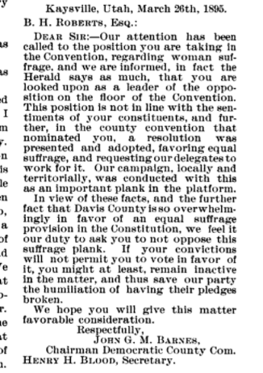
Kaysville, Utah, March 26, 1895

B. H. Roberts, Esq.:

Dear Sir: --Our attention has been called to the position you are taking in the [Utah State Constitutional] Convention, regarding woman suffrage, and we are informed, in fact the Herald [a local newspaper] says as much, that you are looked upon as a leader of the opposition on the floor of the Convention. This position is not in line with the sentiments of your constituents, and further, in the county convention that nominated you, a resolution was presented and adopted, favoring equal suffrage, and requesting our delegates to work for it. Our campaign, locally and territorially, was conducted with this as an important plank in the platform.
In view of these facts, and the further fact that Davis County is so overwhelmingly in favor of an equal suffrage provision in the Constitution, we feel it is our duty to ask you to not oppose this suffrage plank. If your convictions will not permit you to vote in favor of it, you might at least, remain inactive in the matter, and thus save our party the humiliation of having their pledges broken.
We hope you will give this matter favorable consideration.
Respectfully,
John G. M. Barnes,
Chairman Democratic County Committee

