The following excerpt is written by Emmeline B. Wells, editor of the Woman’s Exponent, a woman-run newspaper published in Salt Lake City for 42 years. The Woman’s Exponent featured women’s viewpoints on many women’s rights topics, including suffrage. Wells was a leading suffragist, a polygamous wife, and later in life, General President of the Relief Society, the LDS Church’s organization for women.

“These grand, heroic women [Utah suffragists who attended the National Suffrage Convention in Washington, D.C. to argue for their voting rights] stand forth as champions of justice, and deserve the praise of all men and all women throughout the land for the step they have taken to defend the rights of those, who are, as it were, powerless to act in their own defense, because of the bigotry [hatred for a particular group] and prejudice that exists in this boasted age of enlightenment, and in the country which has proclaimed religious liberty to all mankind.

“Miss [Susan B.] Anthony denounces [to publicly state something is wrong] polygamy, too, but she believes in human rights, nevertheless, and does not sanction [agree with] the taking away, without, at least due process of law, privileges from those who have broken no law whatever. . . .

“[Utah women] have held the ballot sacred and have always been on hand to exercise the right and cast their votes for the men of their choice, those whom they knew to be worthy of the positions to which they were nominated, and like wise and prudent citizens, they have voted for their friends and not for their enemies.”

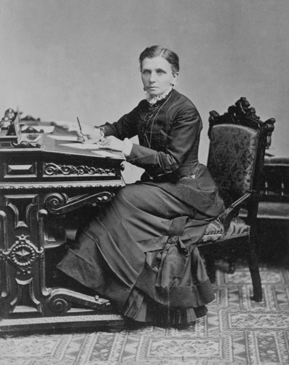
--Excerpt from “Suffrage Women Protest,” Woman’s Exponent, Vol 15, no 17, February 1, 1887, 132.

- What biases may Wells have had about this topic? How do these biases influence your thoughts about her arguments?

- What reasons does Emmeline B. Wells give for Utah women retaining their voting rights? Do you agree or disagree with her reasons? Why or why not?

- Why do you think Wells states Susan B. Anthony’s opinion? Why would readers care about Anthony’s opinion? How does sharing it support Wells’s argument?

- Anti-polygamists claimed that polgyamy was harmful to women. How do you think Wells would respond to these claims?

