The following excerpts are from Orson F. Whitney’s speech at the Utah State Constitutional Convention in 1895. Whitney was a journalist, historian, politician, and later, a leader in the Mormon Church. He served on the Salt Lake City Council, acted as City Treasurer from 1884 to 1890, and served as a State Senator in 1898, and again in 1901.

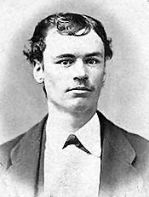
“I believe in a future for woman...I do not believe that she was made merely for a wife, a mother, a cook, and a housekeeper. These callings, however honorable--and no one doubts that they are so--are not the sum of her capabilities.

“It is woman’s destiny to have a voice in the affairs of the government. She was designed for it. She has a right to it.”

“The women of Utah understand what suffrage means. They are not as ignorant as some suppose. They enjoyed the elective franchise for seventeen years, and voted again and again.

“I believe in woman suffrage. I have always believed in it. I look upon it as another step, another impulse of humanity toward perfection.”

“They tell us that woman suffrage in the Constitution will imperil Statehood. I don’t believe it. But if it should, what of it? There are some things higher and dearer than Statehood. I would rather stand by my honor, by my principles, than to have Statehood.”

Excerpt from Utah State Constitutional Convention, 1895.

- What reasons does Whitney give for including women’s suffrage in the Utah state constitution? Do you agree or disagree with his reasons? Why or why not?

- Why did some people oppose including women’s suffrage in the state constitution? How does Whitney respond to their reasons?

