1915 Suffrage Envoy

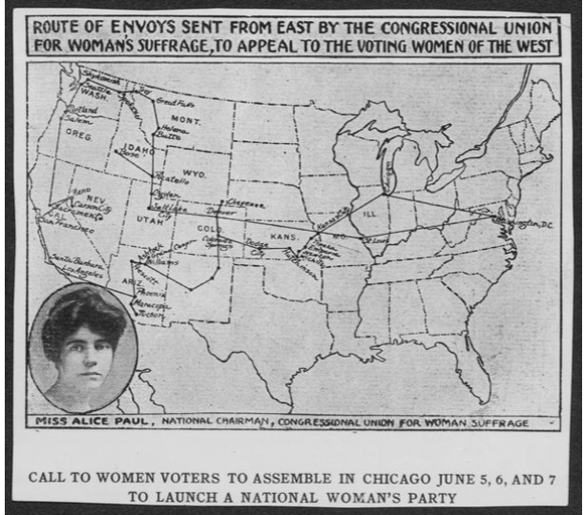
Map of the Suffrage Envoy Route. Courtesy of Library of Congress.

In September 1915, Alice Paul’s Congressional Union of Women Voters collected 500,000 signatures on a suffrage petition that was 18,333 feet and 4 inches long. Suffrage leader Sara Bard Field was selected to lead an envoy to transport the petition cross-country to present it to Congress and President Woodrow Wilson. From September through December 1915, Field traveled with her driver Ingeborg Kinstedt and machinist Maria Kindberg, gaining support for the suffrage amendment and meeting with suffragists throughout the country. The envoy stopped in Salt Lake City on October 4, 1915 and was greeted by the Governor, the Salt Lake City mayor, Emmeline B. Wells, and many other public officials and Utah suffragists in an elaborate parade and official ceremony on the steps of the new Utah State Capitol building. Field addressed the crowd and was welcomed with overwhelming support in Utah, where women had been voting and supporting the suffrage cause for many years.

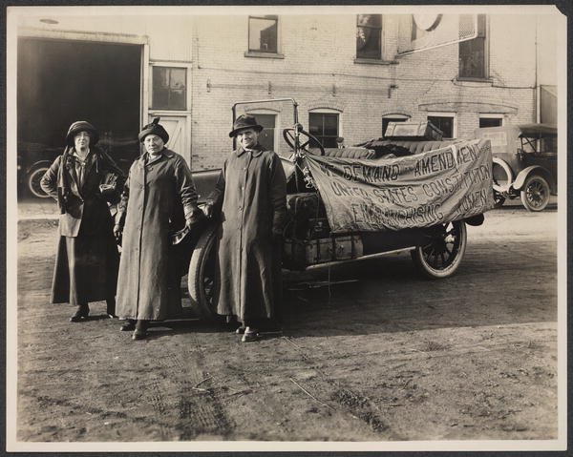
Suffrage envoy Sara Bard Field (left) and her driver, Maria Kindberg (center), and machinist Ingeborg Kindstedt (right) during their cross-country journey to present suffrage petitions to Congress, September-December 1915. Courtesy of Library of Congress.
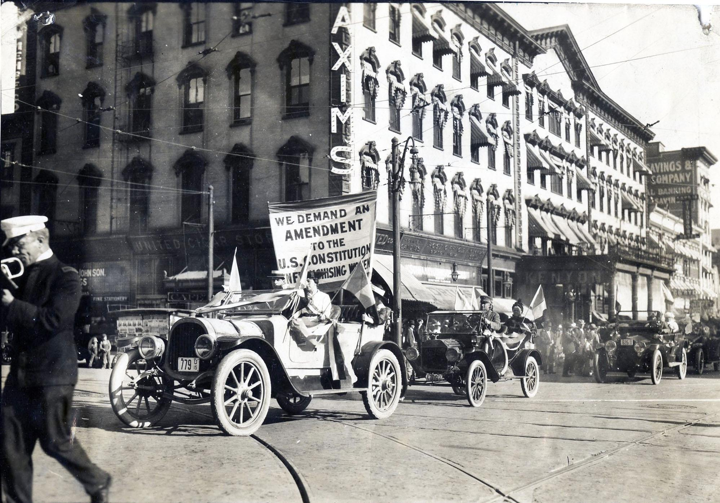
Envoy to Senator Smoot of Utah by delegation of Utah women voters. Parade coming up Main Street, Salt Lake City, on way to interview the senator - 1915. Courtesy of National Woman’s Party.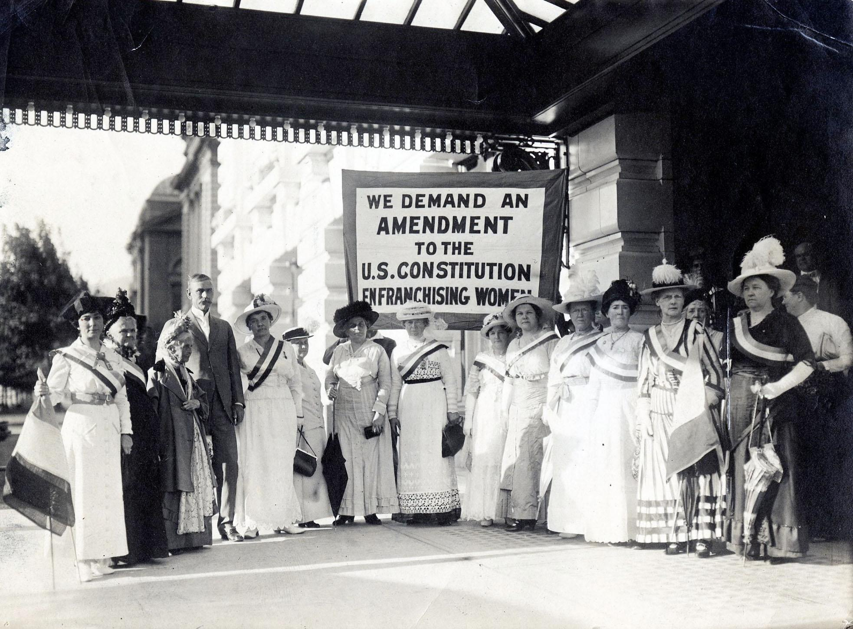
Members of the executive committee of the national suffragists’ convention and prominent local women supporting national political freedom for woman. From L to R: Mrs. Marie Mahon of New York, Mrs. H. S. Lapish, Mrs. Emmeline B. Wells, Senator Reed Smoot, Mrs. W. J. Wolstenhome, Mrs. F. A. Hayward, Mrs. Margaret Zane Cherdron, Mrs. L. A. Clark, Mrs. J. H. Saxson, Mrs. A. D. Paine, Mrs. L. T. Freeze, Mrs. Ruth M. Fox, Mrs. Charles Livingston, Mrs. L. R. Tanner, and Mrs. M. B. Lawrence. Courtesy of National Woman’s Party.

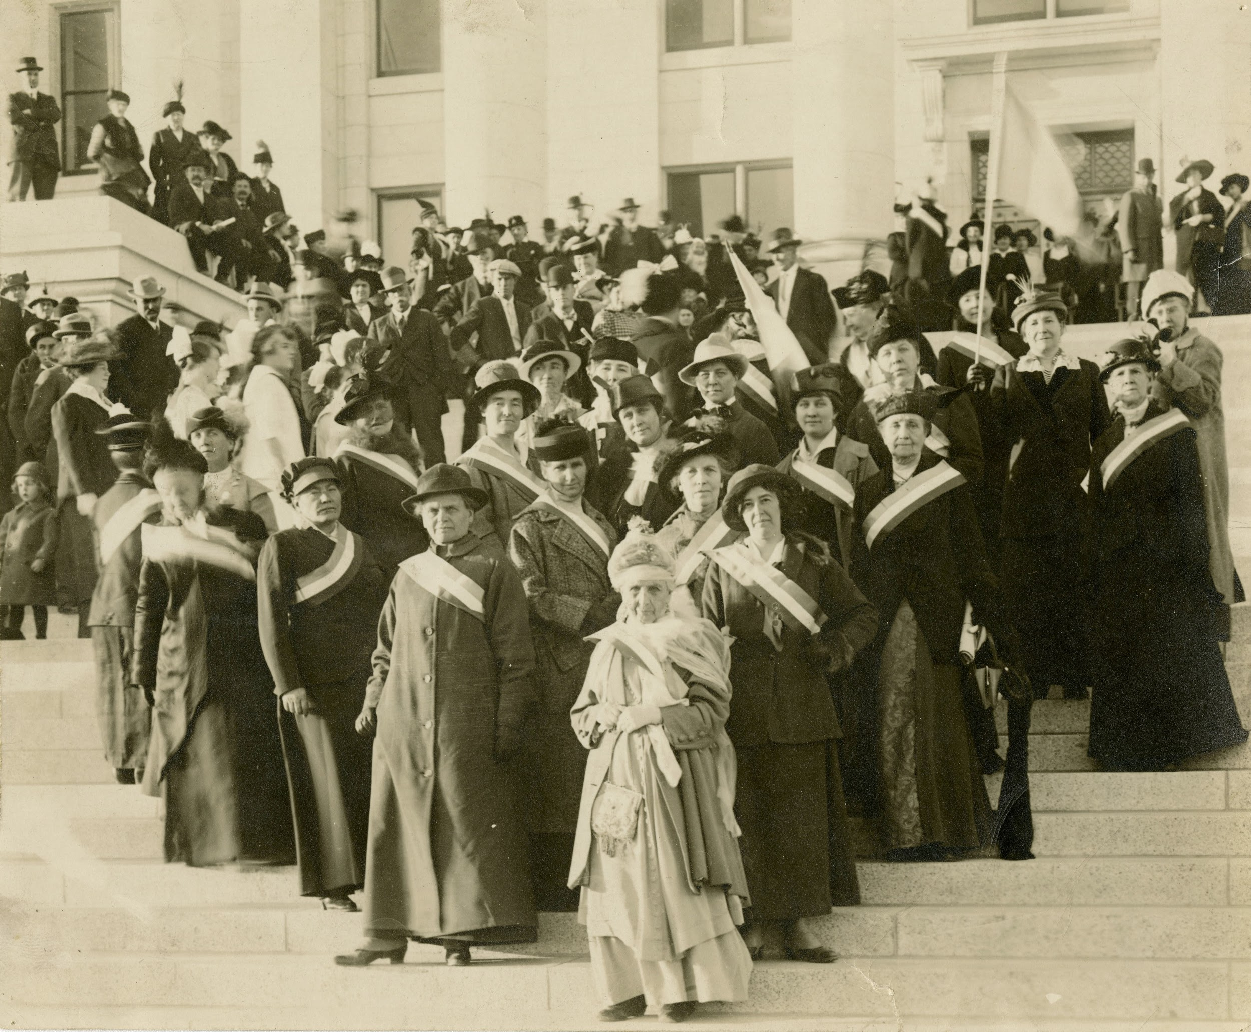
Envoys from San Francisco Exposition carrying petition to Washington D.C. Welcoming envoys, on steps of Utah Capitol - October 16th, 1915. Front (L to R): Maria. A. Kinderberg (driver of the automobile), Ingeborg Kindstedt (machinist), Emmeline B. Wells, and Sara Bard Field (messenger). Courtesy of National Woman’s Party.

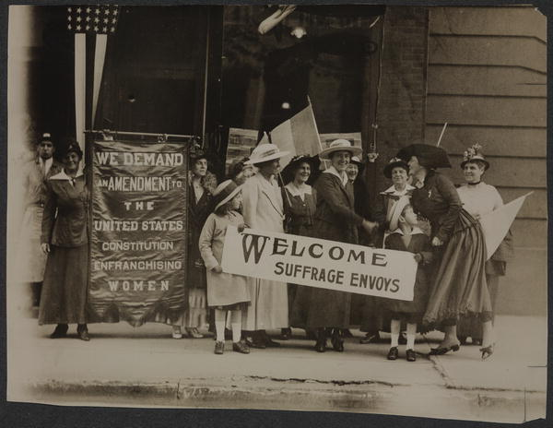
Suffrage envoys from San Francisco greeted in New Jersey on their way to Washington to present a petition to Congress in 1915. This envoy contained more than 500,000 signatures. Courtesy of Library of Congress.
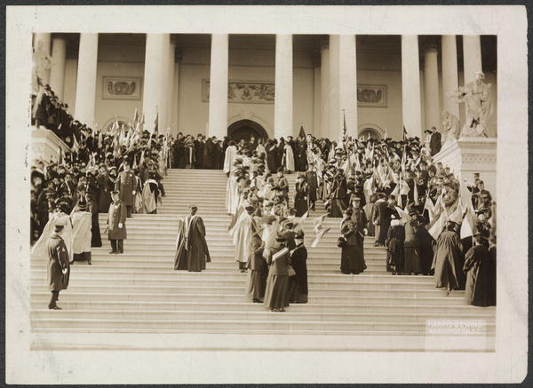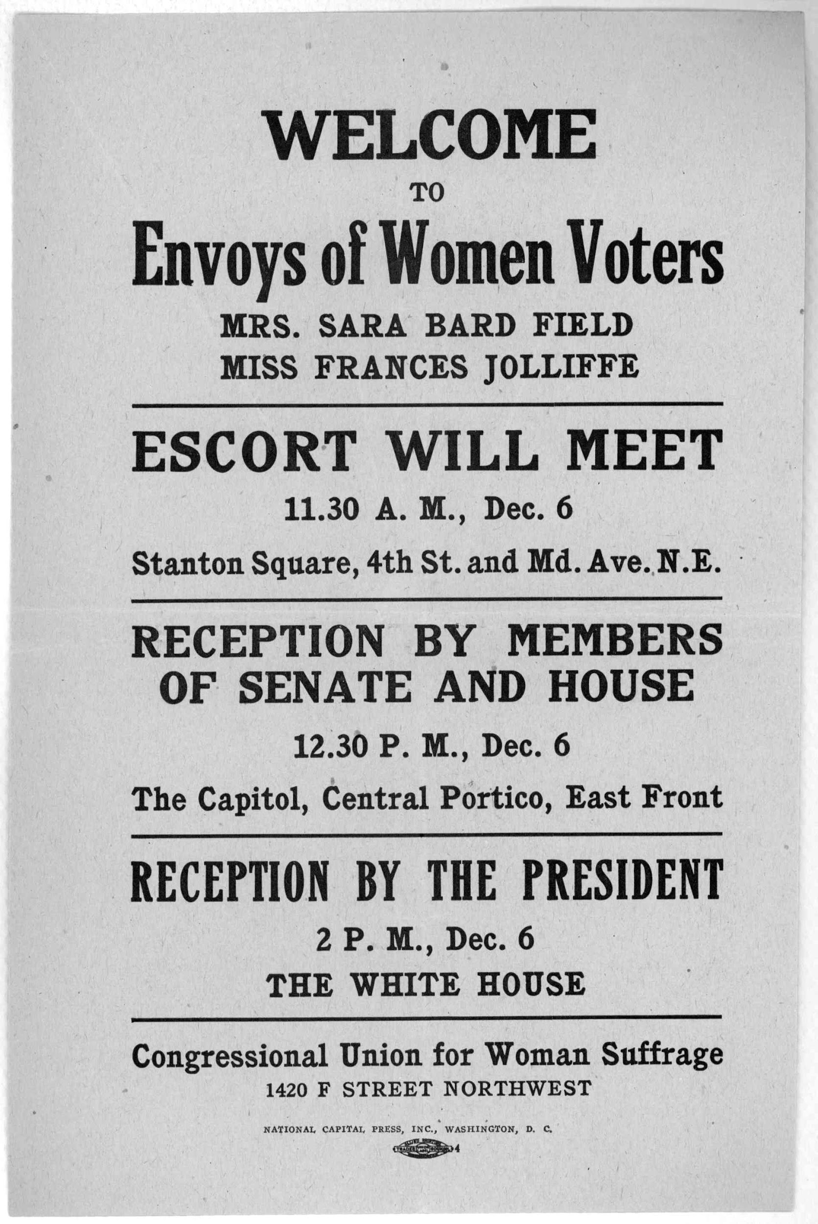
Suffrage Envoy arriving at the U.S. Capitol in Washington, D.C. in December 1915. Courtesy of Library of Congress.
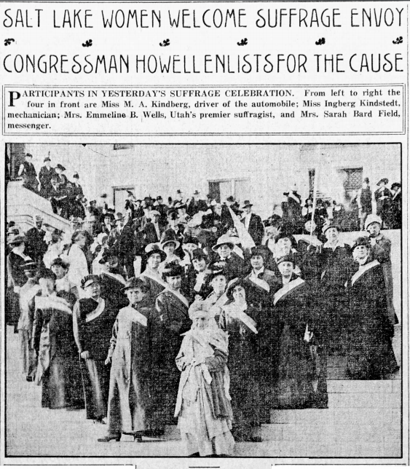

Salt Lake Tribune, October 5, 1915

SALT LAKE WOMEN WELCOME SUFFRAGE ENVOY
CONGRESSMAN HOWELL ENLISTS FOR THE CAUSE
PARTICIPANTS IN YESTERDAY’S SUFFRAGE CELEBRATION. From left to right the four in front are Miss M. A. Kindberg, driver of the automobile; Miss Ingberg Kingstedt, mechanician; Mrs. Emmeline B. WElls, Utah’s premier suffragist, and Mrs. Sarah Bard Field, messenger.

Mrs. Sarah Bard Field Tells of Message She Bears to Congress.
SARAH BARD FIELD, envoy of the Congressional Union of Women Voters to the congress of the United States, delegate at the recent convention in San Francisco to carry to the national congress at Washington the demand of the union for enfranchisement of women, stood militant upon the steps of Utah’s capitol yesterday afternoon without a foe to face. Thereupon Mrs. Field proved herself as skilled in the ways of diplomacy as she is reputed to be in the practice of militancy.
With smiling courtesy Congressman Joseph Howell permitted himself to be enlisted in the cause of suffrage for women, and right boldy and without qualification he declared for the cause. Governor William Spry urbanely explained that Utah had long since solved the suffrage problem in the most satisfactory manner and had gone on along the road of civilization. Mayor Samuel C. Park went on record to the effect that suffrage for women had not complicated politics in Utah, and had been productive of much good.
Mrs. Field arrived in Salt Lake late yesterday afternoon by automobile from San Francisco, in company with Miss M. A. Kindberg and Miss Ingberg Kindstedt, both of Providence R.I. Miss Kindberg is driver and Miss Kindstedt mechanician of the automobile bought in San Francisco expressly for the trip to the national capital. The two went to the exposition by way of the Panama canal. They had determined to return by automobile, and offered to carry the messenger of the Congressional union. Miss Frances Joliffe of San Francisco, sister-in-law of D.C. Jackling, who was to have been of the party, was detained at home by illness. She will meet them in Washington, however, at the time of the presentation of the petition with its million signatures demanding the passage of the Susan B. Anthony amendment to the constitution of the United States. Miss Kindstedt said that she and her companion had decided upon the automobile trip as a means of broadening their acquaintance with American geography, having been embarrassed by their own ignorance upon a recent tour of Europe, when they were called upon to answer many questions.

Welcomed by Women Voters.
The automobile bearing the three, the envoy and her two convoys, all admitted militant suffragettes, was met at Fourteenth South and State streets by ten automobiles loaded with more than a score of Salt Lake’s most prominent women, every one proud of being able to extend the hand of a voter in welcome of Mrs. Field. The procession of cars, decorated with colors of the congressional union, purple, white and gold, proceeded uptown to the Utah hotel. From there they were led to the capitol by Grow & Roberts’ band. The ceremony upon the capitol steps was begun when Mrs. Lizzie Thomas Edward led six white-clad little girls in singing, “Utah, We Love Thee.” Mrs. Field was presented by Mrs. Emmeline B. Wells, who then called upon Governor William Spry and Mayor Samuel C. Park for addresses of welcome.
A short though eloquent and feeling address of welcome to the visitors in behalf of the women of Utah was delivered by Mrs. Annie Wells Cannon, member of the advisory council of the Congressional union. The real triumph of the occasion came when Congressman Howell was presented by Mrs. Margaret Zane Cherdron. Before he was permitted to address the assemblage on the steps of the capitol, Miss Mable Vernon, field secretary of the Congressional union, who preceded Mrs. Field here by train, contrived by an adroit bit of impassioned militant oratory, to bring the state’s representative face to face with the issue. In a rich cello-pitched voice that over-reached the extent of the audience, she demanded to know what was to be done for the 20,000,000 unfranchised women of the nation.

Howell Enlists
As the excellent specimen of a Utah sunset was being poured in extravagant splashes of gold across Great Salt Lake, Congressman Howell took up the gage and answered that he would be for a constitutional amendment to enfranchise them.
Mrs. Field told in stirring sentences of how she had been commissioned to carry the plea of franchisement to the lawmakers of the nation. She referred to it as a demand made by 4,000,000 already enfranchised women in eleven states of the union.
During the reception on the steps of the statehouse Mrs. Thomas Egan, former member of the Drury Lane Opera company, sang Tosti’s “Good Bye” in a voice that was more than equal to the handicap of the out-of-doors. The exercises were concluded with the singing of “America” by the assemblage, led by Mrs. Lizzie Thomas Edward and the six schoolgirls who sang the first number.

Visit State Fair.
With the breaking up of the party on the capitol steps the visitors were escorted to the Hotel Utah and were the guests at dinner of the Utah committee of the Congressional union, Mrs. Cherdron doing the honors. During the evening they visited the state fair.
The women of Salt Lake who took part in the reception and entertainment of the message-bearers were: Mrs. Emmeline B. Wells, Mrs. William Spry, Mrs. Margaret Zane Cheredron, Mrs. Annie Wells Cannon, Mrs. Don Coray, Mrs. J.W. Clawson, Mrs. Lavina Livingston, Mrs. J.W. McHugh, Mrs. F.C. Schramm, Mrs. W.M. Ferry, Mrs. Freeman Morningstar, Mrs. Richard P. Morris, Mrs. James H. Moyle, Mrs. Edward M. Garnett, Mrs. John Malick, Mrs. Joseph Geoghegan, Mrs. C.E. Cook, Mrs. Ernest Bamberger, Mrs. Zina N. Card, Mrs. L.B. McCornick, Mrs. Arthur H. Bird, Mrs. Walker Salisbury, Miss Kate Williams, Mrs. Frank Judge, Mrs. Hannah Lapish, Mrs. F.S. Richards, Mrs. Lucy Clark and Miss Mable Vernon. The Women’s Republican club attended the exercises at the capitol in a body.

