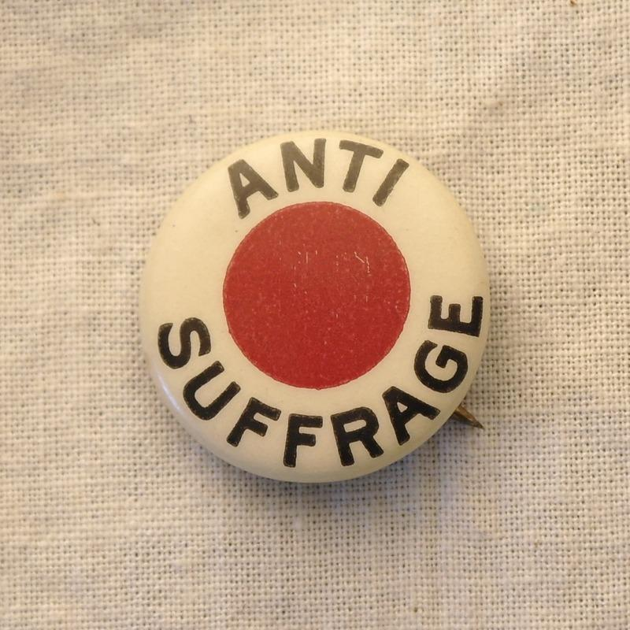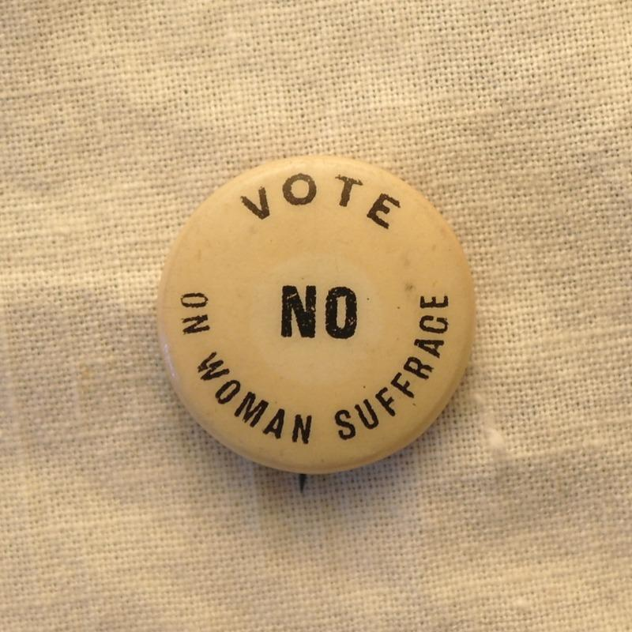

"Official" anti-suffrage colors were most often red, black, and white. The primary anti-suffrage organizations that may have distributed this button were the Massachusetts Association Opposed to the Further Extension of Suffrage (later the Anti-Suffrage Association of Massachusetts) and/or the National Association Opposed to Women Suffrage. 1915.

From the collection of Ann Lewis and Mike Sponder.

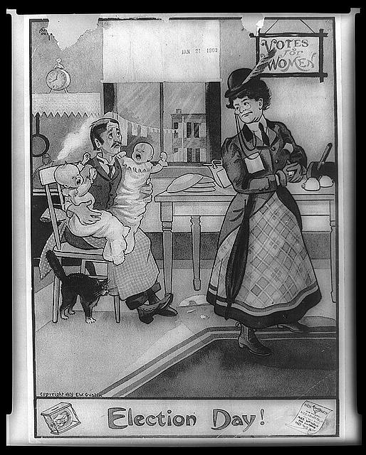

This image shows a woman on her way to go vote and leaving behind her husband with two crying babies and a dirty house. It illustrated the arguments of anti-suffragists that women would abandon their household responsibilities and families would suffer if women were given the right to vote.

Election Day!. Photograph. Retrieved from the Library of Congress, <www.loc.gov/item/97500226/>.

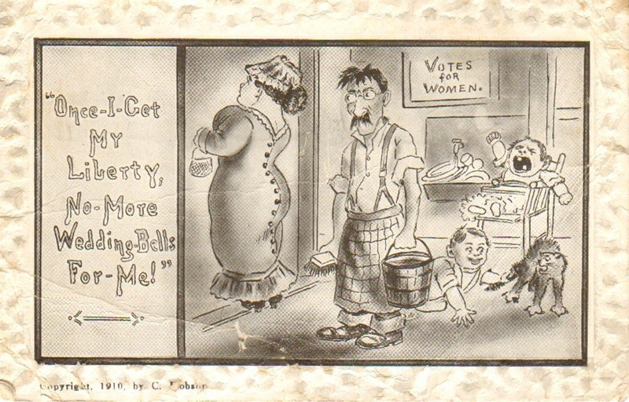

This 1910 image shows a woman leaving the home while her husband is left behind to care for the dirty home and crying children. The caption, “Once I get my liberty, no more wedding bells for me!” played on the fears of those opposed to women’s suffrage that women would abandon their families and damage home life if suffrage was granted.

From the collection of Ann Lewis and Mike Sponder.

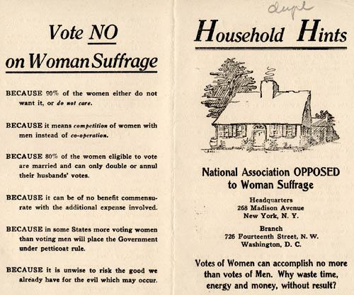
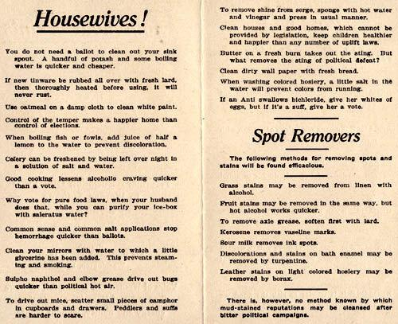
This pamphlet was distributed by the National Association Opposed to Woman Suffrage. It contained reasons why women did not need to vote. Many women found these ideas rather offensive; however, there were some who did agree with them. In addition to the anti-suffrage language, the pamphlet caught women’s attention with its title “Household Hints” and inside there was useful household advice. These suggestions, like “Sour milk removes ink spots,” provided women with easy solutions to common issues while also encouraging them to not “waste time, energy and money” by voting. Description from National Women’s History Museum.
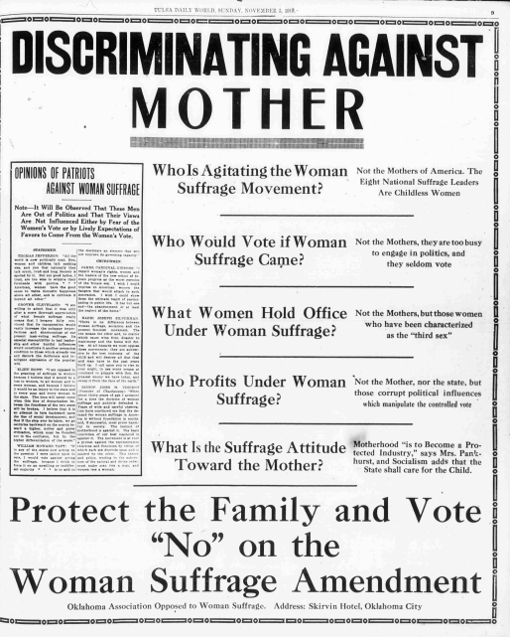

"Discriminating Against Mother." Tulsa Daily World. (Tulsa, Indian Territory [Okla.]), 03 Nov. 1918. Courtesy of Chronicling America: Historic American Newspapers. Library of Congress. http://chroniclingamerica.loc.gov/lccn/sn85042344/1918-11-03/ed-1/seq-31/

These are excerpts from a speech given by Senator J.B. Sanford, the Chairman of the California Democratic Caucus, in 1911. He argued against the California suffrage amendment and called on others to “keep woman where she belongs.”

Argument Against Women's Suffrage, 1911
Prepared by J. B. Sanford, Chairman of California Democratic Caucus

ARGUMENT AGAINST SENATE CONSTITUTIONAL AMENDMENT NO. 8

Suffrage is not a right. It is a privilege that may or may not be granted. Politics is no place for a women consequently the privilege should not be granted to her.

The mother's influence is needed in the home...Let her teach her daughters that modesty, patience, and gentleness are the charms of a women. Let her teach her sons that an honest conscience is every man's first political law...The mothers of this country can shape the destinies of the nation by keeping in their places and attending to those duties that God Almighty intended for them…

The men are able to run the government and take care of the women. Do women have to vote in order to receive the protection of man? ...To man, woman is the dearest creature on earth, and there is no extreme to which he would not go for his mother or sister...Woman does not have to vote to secure her rights. Man will go to any extreme to protect and elevate her now…

Woman suffrage has been proven a failure in states that have tried it. It is wrong...On the contrary, statistics go to show that in most equal suffrage states, Colorado particularly, that divorces have greatly increased since the adoption of the equal suffrage amendment, showing that it has been a home destroyer. Crime has also increased due to lack of the mothers in the home...Let her be content with her lot and perform those high duties intended for her by the Great Creator...Let the manly men and the womanly women defeat this amendment and keep woman where she belongs in order that she may retain the respect of all mankind.

Source: J. B. Sanford, Senator 4th District. Received by Secretary of State Frank Jordan on June 26th, 1911, for publication as part of a voters' information manual. Document is currently filed in the California State Archives under: Secretary of State Elections Papers, 1911 Special Election.

