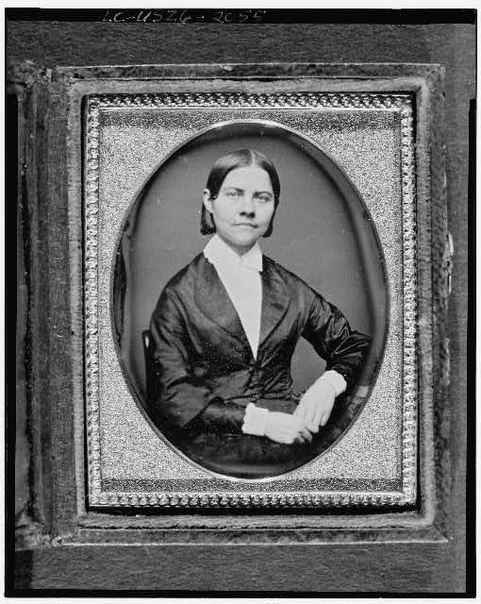
Lucy Stone was a prominent suffragist who organized the first National Woman’s Rights Convention and who later organized the American Woman Suffrage Association. She gave this famous impromptu speech on October 17, 1855 at a National Woman’s Rights Convention in Cincinnati in response to a heckler who interrupted the proceedings to call the female speakers “a few disappointed women.” Stone responded that she was indeed a “disappointed woman,” and argued that the limitations of “women’s sphere” created injustice and disappointment for women in educational, professional, religious, marriage, and other pursuits.

Disappointment is the Lot of Women
By Lucy Stone

From the first years to which my memory stretches, I have been a disappointed woman. When, with my brothers, I reached forth after the sources of knowledge, I was reproved with “It isn’t fit for you; it doesn’t belong to women.” Then there was but one college in the world where women were admitted, and that was in Brazil. I would have found my way there, but by the time I was prepared to go, one was opened in the young State of Ohio—the first in the United States where women and Negroes could enjoy opportunities with white men. I was disappointed when I came to seek a profession worthy an immortal being—every employment was closed to me, except those of the teacher, the seamstress, and the housekeeper. In education, in marriage, in religion, in everything, disappointment is the lot of woman. It shall be the business of my life to deepen this disappointment in every woman’s heart until she bows down to it no longer. I wish that women, instead of being walking showcases, instead of begging of their fathers and brothers the latest and gayest new bonnet, would ask of them their rights.

The question of Woman’s Rights is a practical one. The notion has prevailed that it was only an ephemeral idea; that it was but women claiming the right to smoke cigars in the streets, and to frequent bar rooms. Others have supposed it a question of comparative intellect; others still, of sphere. Too much has already been said and written about woman’s sphere. Trace all the doctrines to their source and they will be found to have no basis except in the usages and prejudices of the age. This is seen in the fact that what is tolerated in woman in one country is not tolerated in another...Leave women, then, to find their sphere. And do not tell us before we are born even, that our province is to cook dinners, darn stockings, and sew on buttons.

We are told woman has all the rights she wants; and even women, I am ashamed to say, tell us so. They mistake the politeness of men for rights—seats while men stand in this hall tonight, and their adulations; but these are mere courtesies. We want rights. The flour merchant, the house builder, and the postman charge us no less on account of our sex; but when we endeavor to earn money to pay all these, then, indeed, we find the difference. Man, if he have energy, may hew out for himself a path where no mortal has ever trod, held back by nothing but what is in himself; the world is all before him, where to choose; and we are glad for you, brothers, men, that is so...Women working in tailor shops are paid one-third as much as men...Woman must marry for a home, and you men are the sufferers by this; for a woman who loathes you may marry you because you have the means to get money which she can not have. But when woman can enter the lists with you and make money for herself, she will marry you only for deep and earnest affection...

The widening of woman’s sphere is to improve her lot. Let us do it, and if the world scoff, let it scoff—if it sneer, let it sneer.

Source: “Disappointment Is the Lot of Women” by Lucy Stone. Reprinted in History of Woman Suffrage, vol. 1, edited by Elizabeth Cady Stanton (New York: Fowler and Wells, 1922), pp. 165–167.

Photo courtesy of Library of Congress. Lucy Stone between 1840-1860.

