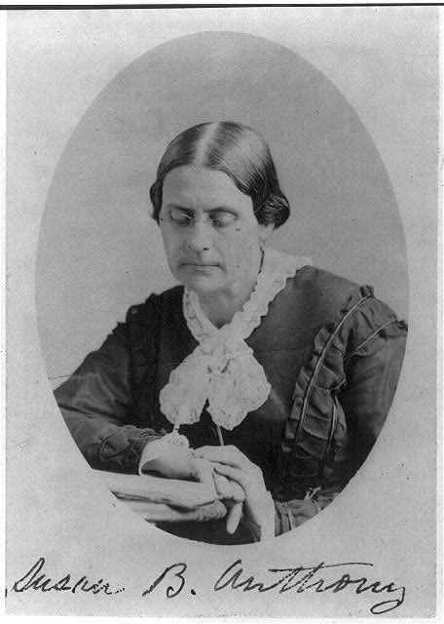
Susan B. Anthony began as a speaker for the abolition movement and later used those skills and passion to lead the women’s rights movement. This powerful speech from 1859 linked the circumstances of American women with the oppression of enslaved African Americans. Anthony urged her listeners to “make the slave’s case our own” and to recognize the slave’s humanity.

Excerpts from “Make the Slave’s Case Our Own” (1859)
By Susan B. Anthony

We are assembled here, this evening, for the purpose of discussing the question of American Slavery: – – The startling fact that there are in these United States, under the sanction of this professedly Christian, Republican Government, nearly Four millions of human beings now clanking the chains of Slavery. — Four millions of men and women and children, who are owned like horses and cattle, – and bought and sold in the market. —Four millions of thinking, acting, conscious beings, like ourselves, driven to unpaid toil, from the rising to the setting of the sun, through the weary days and years of their wretched life times.

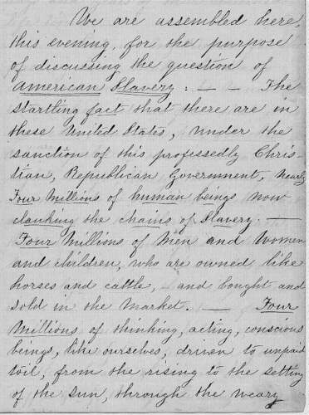
Let us, my friends, for the passing hour, make the slave’s case our own. As much as in us lies, let us feel that it is ourselves...that it is our own backs that are bared to the slave driver’s lash. That it is our own flesh that is lacerated and torn. That it is our own life blood that is poured out…

But we are wont to contemplate this question of slavery from quite another, and an opposite, standpoint. We look upon the slave, as a being all unlike ourselves...we quiet our consciences with the thought that these poor creatures, however wronged and outraged there condition here, are yet, infinitely better off than they would be in their African homes across the Atlantic. Their Fathers were wild beasts living in tents, on the hills of Congo, the arid plains of Soudan, or the coasts of Guinea. And there, in their native own land, were they hunted like beasts of prey, and made to drag out their lives in a hopeless bondage to their more powerful, warlike and treacherous neighbors.

Just think of it, my friends, a civilization elevating and refining, that makes slaves and chattels of one sixth portion of its own children, and with iron heel, crushes out their every spark of manhood. A civilization that, by statute law, denies to every sixth man, woman and child, all its educational, industrial, social and political rights and privileges. Such is our boasted American civilization...

Again, it is argued that we of the North are not responsible for the crime of slave holding, that the guilty ones dwell in the South...Thus, do we put the slave’s case far away from us, forgetting that he is a human being like ourselves, forgetting that we ourselves are bound up with the slaveholder, in his guilt, forgetting that we of the North stand pledged to the support of the Federal Government...More than all, forgetting that we of the North, welcome slaveholding priests to our pulpits, and slave-holding laymen to our church conferences...

But as a nation, we do deny the manhood of the slave, both politically and religiously. And it is this failure to recognize the slave’s humanity that keeps him in his chains. From the very hour of the foundation of this government has slavery been considered a national curse…

And yet after seventy years of such labors and such prayers, what do we see? Why, the number of slaves increased from a half a million to nearly four millions, the number of slave states from six to fifteen, one thousand millions of dollars pours out of the public treasury for the purchase and conquest of new slave territory – all the United States territories, at first, consecrated to freedom, then thrown open, every foot of them, to the desecrating tread of the slave-holders – the nominally free states, by the late decision of the Supreme Court, made the home of the slave-holder and his slave property...

Source: “Make the slave's case our own.” [ca. 1859]. Susan B. Anthony Papers. Manuscript Division. Library of Congress, Washington, D.C.

Photo: 1) Susan B. Anthony in 1870. Courtesy of Library of Congress. 2) Original copy of Anthony’s speech. Courtesy of Library of Congress.

