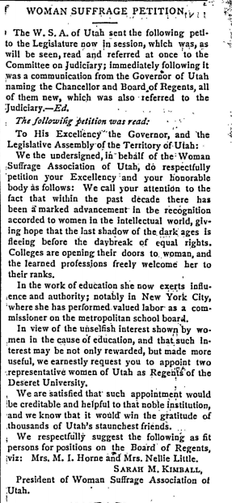
WOMAN SUFFRAGE PETITION.
in Woman’s Exponent, March 15, 1890, Vol. 18, No. 20

The W. S. A. of Utah sent the following petition to the Legislature now in session, which was, as will be seen, read and referred at once to the Committee on Judiciary; immediately following it was a communication from the Governor of Utah naming the Chancellor and Board of Regents, all of them new, which was also referred to the Judiciary. -- Ed.

The following petition was read:

To His Excellency the Governor, and the Legislative Assembly of the Territory of Utah:
We the undersigned, in behalf of the Woman Suffrage Association of Utah, do respectfully petition your Excellency and your honorable body as follows: We call your attention to the fact that within the past decade there has been a marked advancement in the recognition accorded to women in the intellectual world, giving hope that the last shadow of the dark ages is fleeing before the daybreak of equal rights. Colleges are opening their doors to woman, and the learned professions freely welcome her to their ranks.
In the work of education she now exerts influence and authority; notably in New York City, where she has performed valued labor as a commissioner on the metropolitan school board.
In view of the unselfish interest show by women in the cause of education, and that such interest may not only [be] rewarded, but made more useful, we earnestly request you appoint two representative women of Utah as the Regents of Deseret University.
We are satisfied that such appointment would be creditable and helpful to that noble institution, and we know that it would win gratitude of thousands of Utah’s staunchest friends.
We respectfully suggest the following as fit persons for position on the Board of Regents, viz: Mrs. M. I. Horne and Mrs. Nellie Little.
Sarah M. Kimball
President of Woman Suffrage Association of Utah

Excerpts from “IS IT A CRIME FOR A U.S. CITIZEN TO VOTE?”
By Susan B. Anthony
January 1873
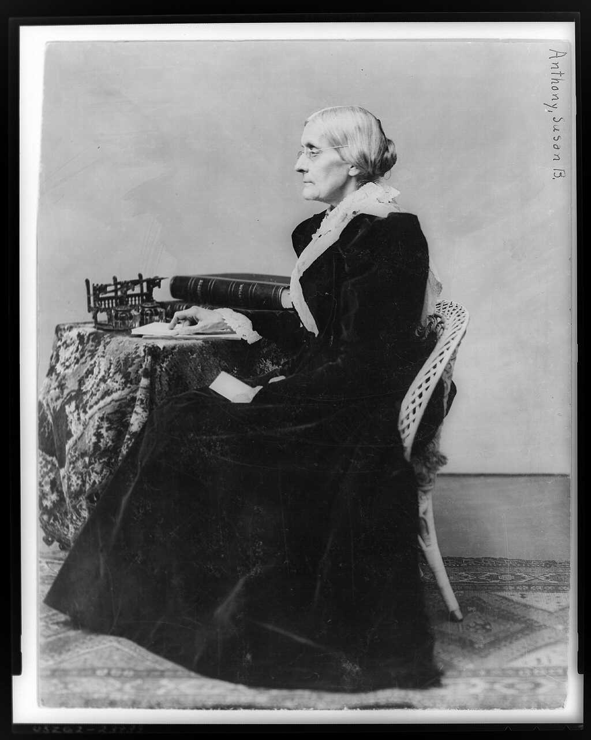
This speech was given by Susan B. Anthony, one of the most prominent national suffrage leaders, after she was arrested and fined $100 for casting a vote in the presidential election of 1872. Her vote was illegal because women did not have the right to vote at that time. She argued that as a citizen of the United States, the Constitution protected her rights and that women should not be disfranchised.
_____________________________________________________

Friends and fellow citizens: I stand before you tonight under indictment for the alleged crime of having voted at the last presidential election, without having a lawful right to vote. It shall be my work this evening to prove to you that in thus voting, I not only committed no crime, but, instead, simply exercised my citizen's rights, guaranteed to me and all United States citizens by the National Constitution, beyond the power of any state to deny.

The preamble of the Federal Constitution says:
"We, the people of the United States, in order to form a more perfect union, establish justice, insure domestic tranquillity, provide for the common defense, promote the general welfare, and secure the blessings of liberty to ourselves and our posterity, do ordain and establish this Constitution for the United States of America."

It was we, the people; not we, the white male citizens; nor yet we, the male citizens; but we, the whole people, who formed the Union. And we formed it, not to give the blessings of liberty, but to secure them; not to the half of ourselves and the half of our posterity, but to the whole people - women as well as men. And it is a downright mockery to talk to women of their enjoyment of the blessings of liberty while they are denied the use of the only means of securing them provided by this democratic-republican government - the ballot.

For any state to make sex a qualification that must ever result in the disfranchisement of one entire half of the people, is to pass a bill of attainder, or, an ex post facto law, and is therefore a violation of the supreme law of the land. By it the blessings of liberty are forever withheld from women and their female posterity.

To them this government has no just powers derived from the consent of the governed. To them this government is not a democracy. It is not a republic. It is an odious aristocracy; a hateful oligarchy of sex; the most hateful aristocracy ever established on the face of the globe; an oligarchy of wealth, where the rich govern the poor. An oligarchy of learning, where the educated govern the ignorant, or even an oligarchy of race, where the Saxon rules the African, might be endured; but this oligarchy of sex, which makes father, brothers, husband, sons, the oligarchs over the mother and sisters, the wife and daughters, of every household - which ordains all men sovereigns, all women subjects, carries dissension, discord, and rebellion into every home of the nation.

The only question left to be settled now is: Are women persons? And I hardly believe any of our opponents will have the hardihood to say they are not. Being persons, then, women are citizens; and no state has a right to make any law, or to enforce any old law, that shall abridge their privileges or immunities. Hence, every discrimination against women in the constitutions and laws of the several states is today null and void, precisely as is every one against Negroes.

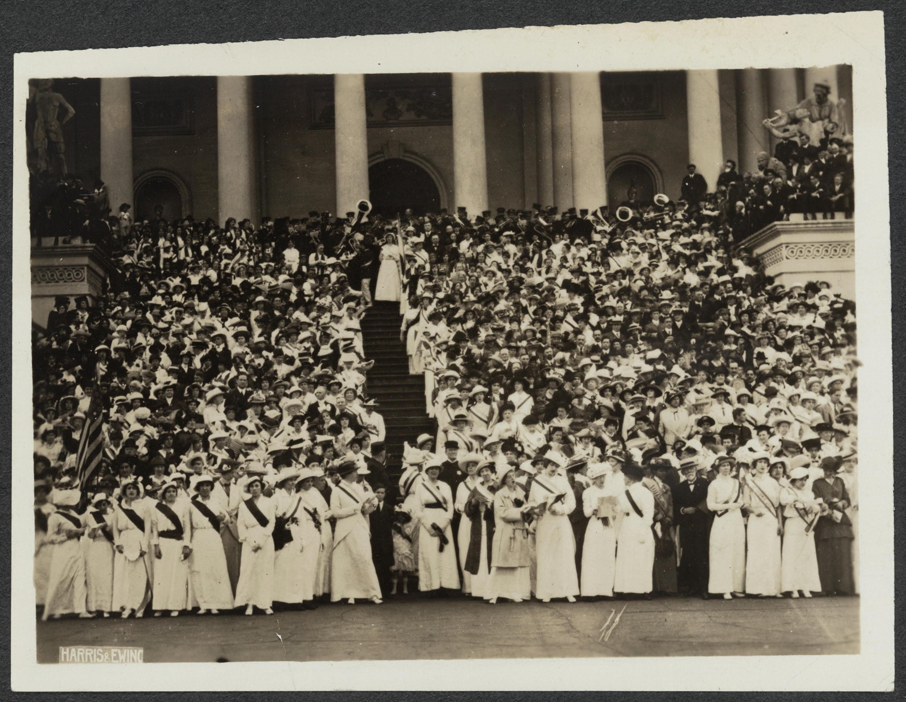
Nationwide demonstrations were held on May 2nd in support of a federal amendment. Envoys from these demonstrations brought petitions to Washington D.C. on May 9th and carried them in procession to Congress. Five thousand women convened on the U.S. Capitol steps singing. Courtesy of Library of Congress.

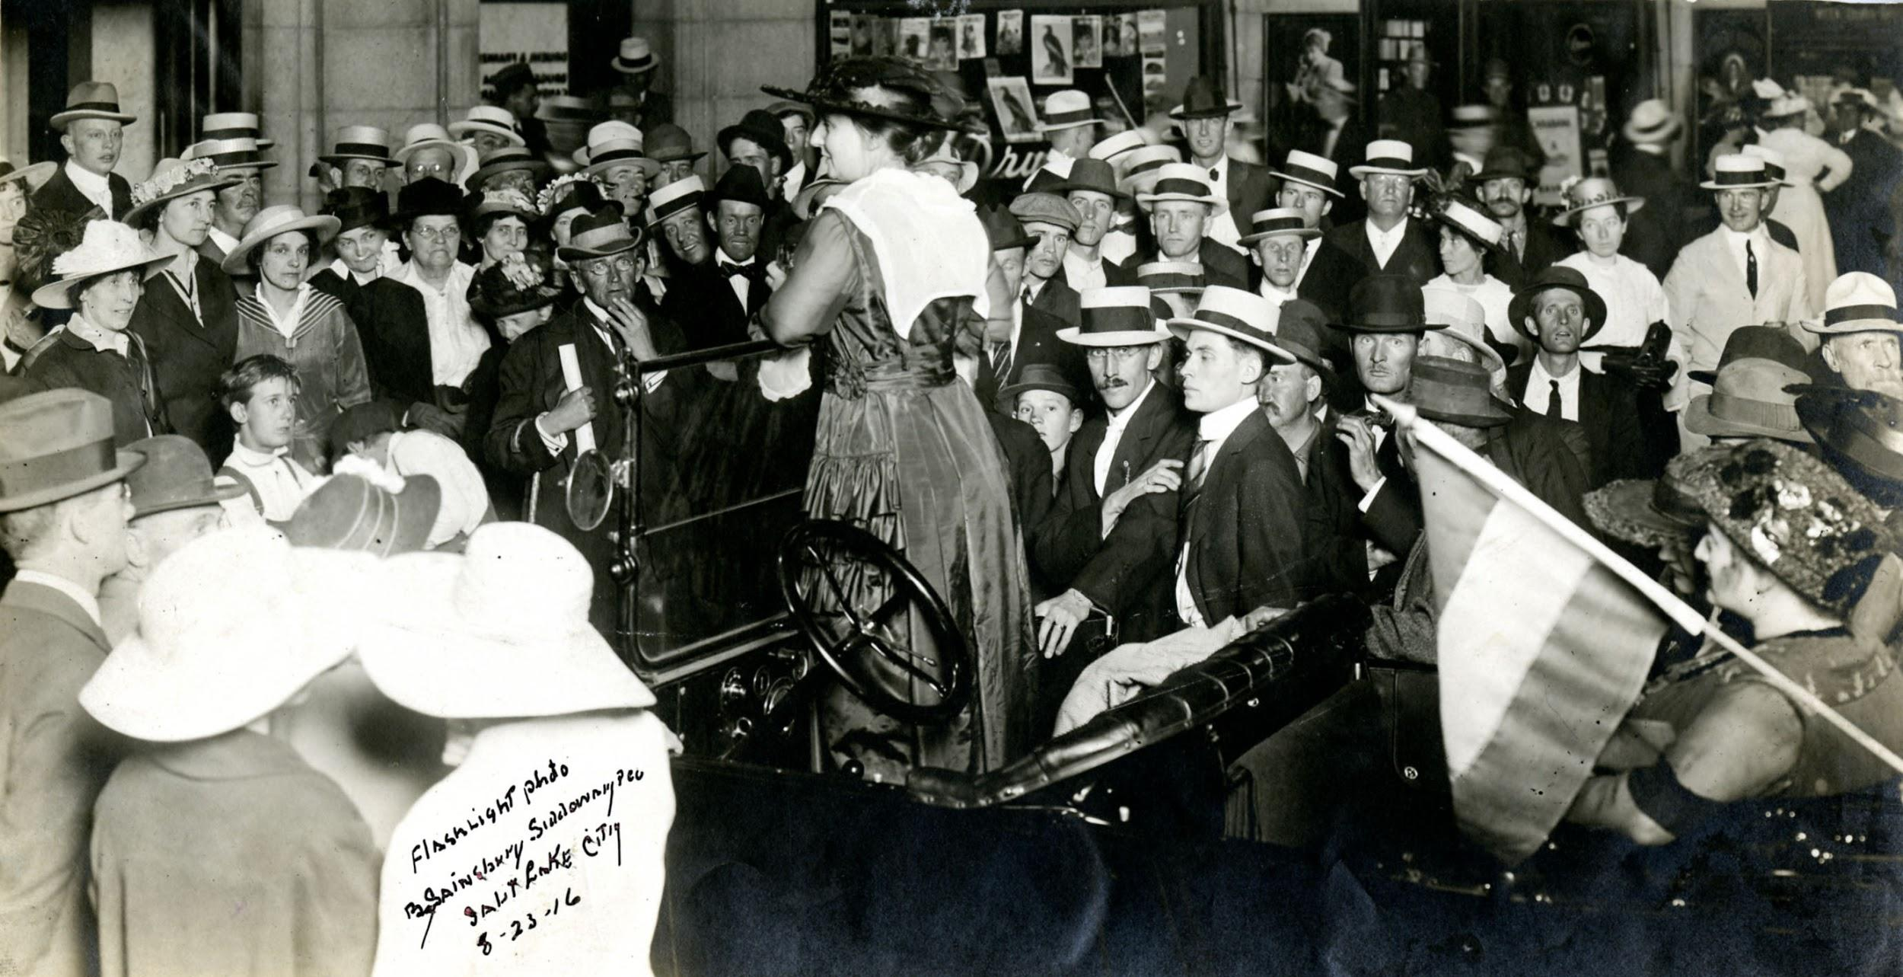
Emily Perry stands in a car surrounded by a large crowd at an open-air suffrage meeting in Salt Lake City, Utah. A tricolor suffrage flag hangs from the back of the car - September 1st, 1916. Courtesy of National Woman’s Party.

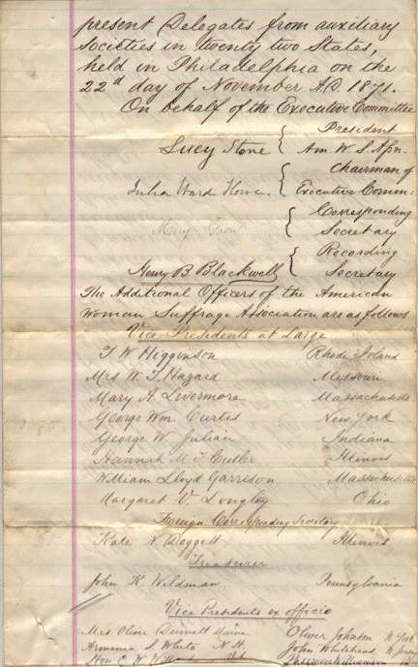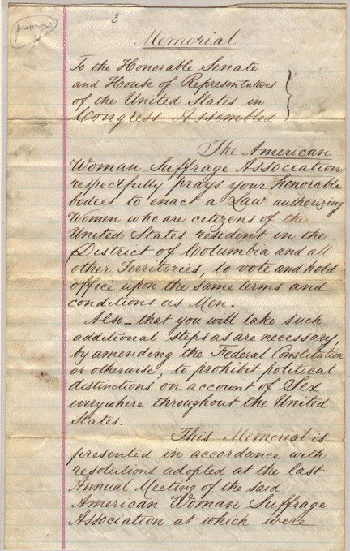

The American Woman Suffrage Association (AWSA) was formed in 1869 after the suffrage movement split over disagreements regarding support for the 15th amendment and strategies on achieving suffrage. AWSA, which was the more moderate suffrage organization, was led by Lucy Stone, Julia Ward Howe, Henry Ward Beecher, and Henry Blackwell. This petition, submitted to Congress in 1871, requested that the U.S. Senate and House of Representatives pass a bill granting women the right to vote and to hold office.

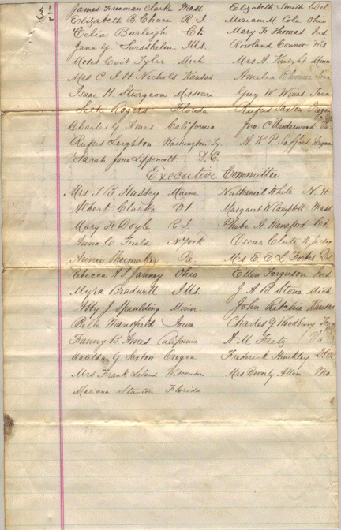

Source: Record Group 233 Records of the U.S. House of Representatives National Archives and Records Administration

Memorial
To the Honorable Senate and House of Representatives of the United States in Congress Assembled:

The American Woman Suffrage Association respectfully prays for your honorable bodies to enact a law authorizing women who are citizens of the United States resident in the District of Columbia and all other Territories, to vote and hold office upon the same terms and conditions as men.

Also--that you will take such additional steps as are necessary, by amending the Federal Constitution or otherwise, to prohibit political distinctions on account of Sex everywhere throughout the United States.

This memorial is presented in accordance with resolutions adopted at the last Annual Meeting of the said American Woman Suffrage Association at which were present Delegates from auxiliary societies in twenty-two States, held in Philadelphia on the 22nd day of November A.D. 1871.

On behalf of the Executive Committee:

Lucy Stone
President

Julia Ward Howe
Chairman of Executive Committee

??
Corresponding Secretary

Henry B Blackwell
Recording Secretary

<Followed by additional signatures of organization leaders>

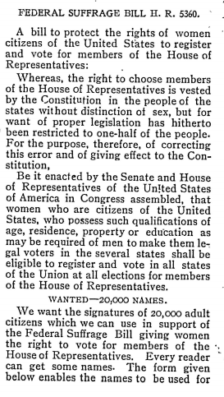

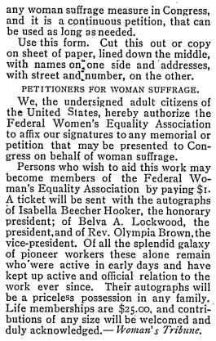

Printed in the Woman’s Exponent, November 11, 1906, Volume 35, Number 5.

FEDERAL SUFFRAGE BILL H. R. 5360
A bill to protect the rights of women citizens of the United States to register and vote for members of the House of Representatives:
Whereas, the right to choose members of the House of Representatives is vested by the Constitution in the people of the states without distinction of sex, but for want of proper legislation has hitherto been restricted to one-half the people. For the purpose, therefore, of correcting this error, and of giving effect of the Constitution,
Be it enacted by the Senate and House of Representatives of the United States of America in Congress assembled, that women who are citizens of the United States, who possess such qualifications of age, residence, property or education as may be required of men to make them legal voters in the several states shall be eligible to register and vote in all states of the Union of all elections for members of the House of Representatives.
WANTED--20,000 NAMES.
We want the signatures of 20,000 adult citizens which can use in support of the Federal Suffrage Bill giving women the right to vote for members of the House of Representatives. Every reader can get some names. The form given below enables the names to be used for any woman suffrage measure in Congress, and it is a continuous petition, that can be used as long as needed.
Use this form. Cut this out and copy on sheet of paper, lined down the middle, with names on one side, and addresses, with street and number, on the other.
PETITIONERS FOR WOMAN SUFFRAGE.
We, the undersigned adult citizens of the United States, hereby authorize the Federal Women’s Equality Association to affix our signatures to any memorial or petition that may be presented to Congress on behalf of woman suffrage.
Persons who wish to aid in this work may become members of the Federal Women’s Equality Association by paying $1. A ticket will be sent with the autographs of Isabella Beecher Hooker, the honorary president; of Belva A. Lockwood, the president; and of Rev. Olympia Brown, the vice-president. Of all the splendid galaxy of pioneer workers these alone remain who were active in the early days and have kept up active and official relation to the work ever since. Their autographs will be a priceless possession in any family. Life memberships are $25.00 and contributions of any size will be welcomed and duly acknowledged. --Woman’s Tribune.

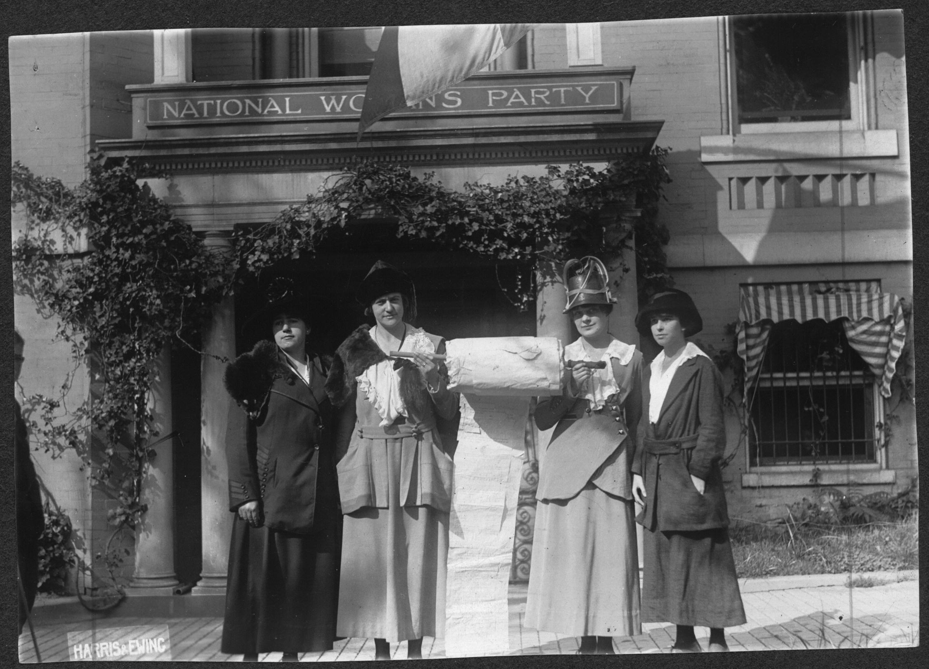Suffragists (left to right: Annie Fraher, Bertha Moller, Berthe Arnold, and Anita Pollitzer) leaving National Woman’s Party headquarters to deliver a petition to Senator Jones of New Mexico. Notice how the petition is on a large scroll, bearing all of the thousands of signatures. Courtesy of Library of Congress.

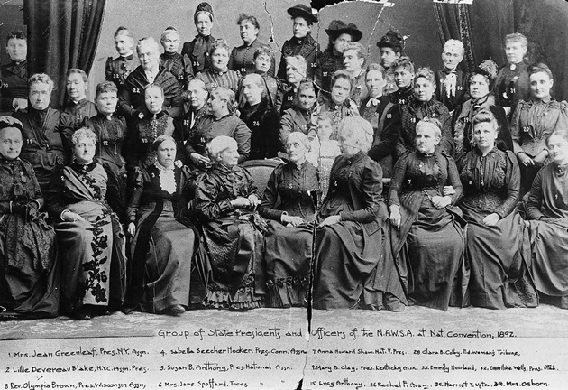
Group of State Presidents and Officers of the N.A.W.S.A. at National Convention, 1892. Courtesy of Bryn Mawr Special Collections.

- Mrs. Jean Greenleaf, Pres. N.Y. Assn.
- Lillie Devereau Blake, N.Y.C. Assn. Pres.
- Rev. Olympia Brown, Pres. Wisconsin Assn.
- Isabella Beecher Hocker, Pres. Conn. Assn.
- Susan B. Anthony, Pres. National Assn.
- Mrs. Jane Spoffard, Treas. “ “
- Anna Howard Shaw, Nat. V. Pres.
- Mary B. Clay, Pres. Kentucky Assn.
- Sarah M. Kimball, Utah
- Emmeline Wells, Pres. Utah
- Lucy Anthony
- Rachel Foster Avery
- Clara B. Colby, Ed. Woman’s Tribune
- Emily S. Richards, Utah
- Emmily Howland
- Mrs. Osborn
- Harriet T. Upton

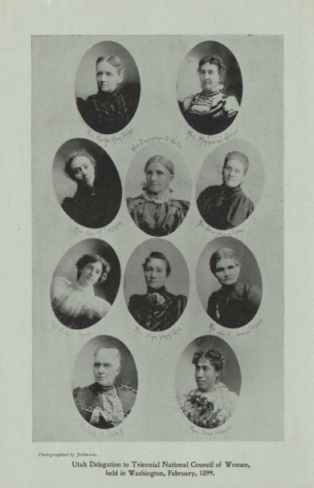
Utah Delegation to Triennial National Council of Women, held in Washington, February 1899. Courtesy of LDS Church History Library.

Top row (L to R): Mrs. Martha Horn Tingey, Mrs. Minnie J. Snow
2nd row: Miss Ann M. Cannon, Mrs. Emmeline B. Wells, Mrs. Susa Young Gates
3rd row: Miss Mabel Snow, Mrs. Zina Young Card, Mrs. Lulu L. Greene Richards
Bottom row: Mrs. Lucy B. Young, Miss Hannah Kaaepa

