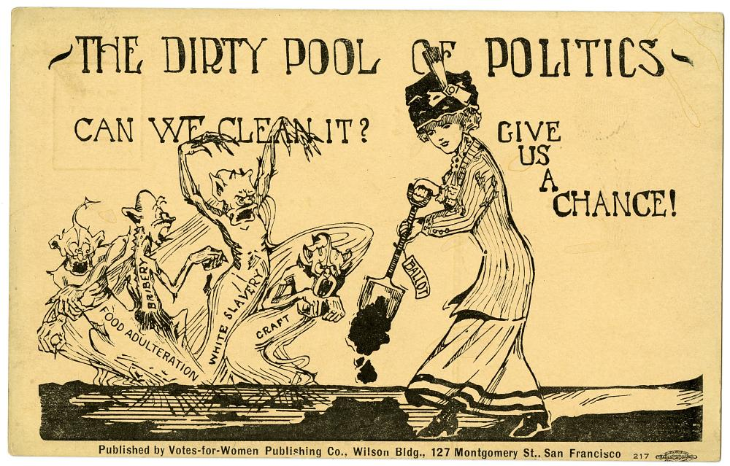

Women spoke against the anti-suffrage argument that they were too pure for the dirty business of politics by using arguing that women’s ability to clean and order their homes also meant that they could use these skills to cure the evils of society.
The postcard was part of a 1911 campaign for suffrage in California, which became the sixth state to approve women’s suffrage.

Description and Image Courtesy of National Museum of American History.

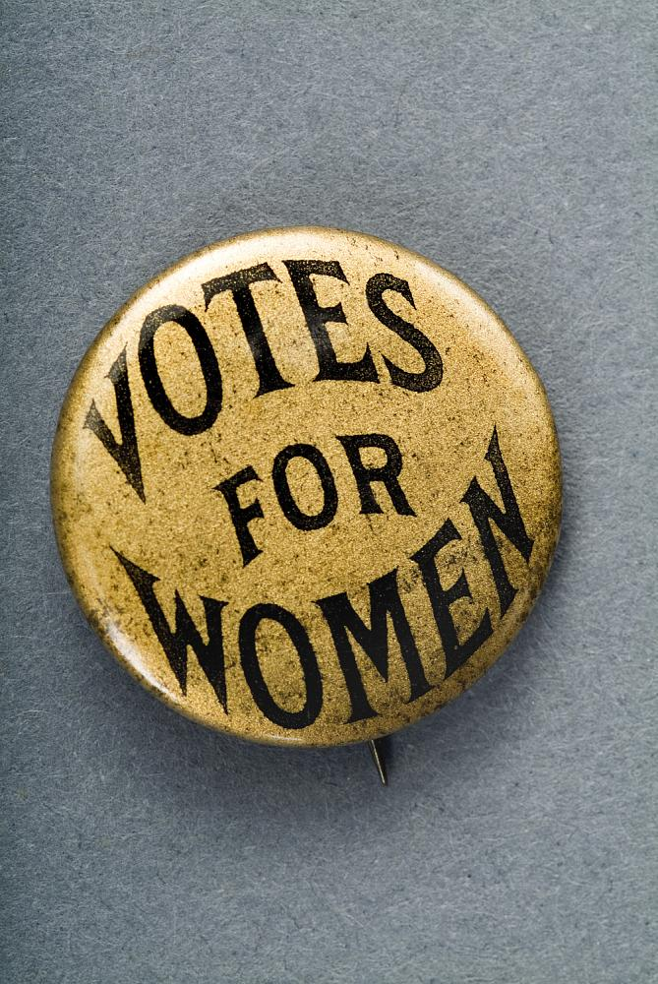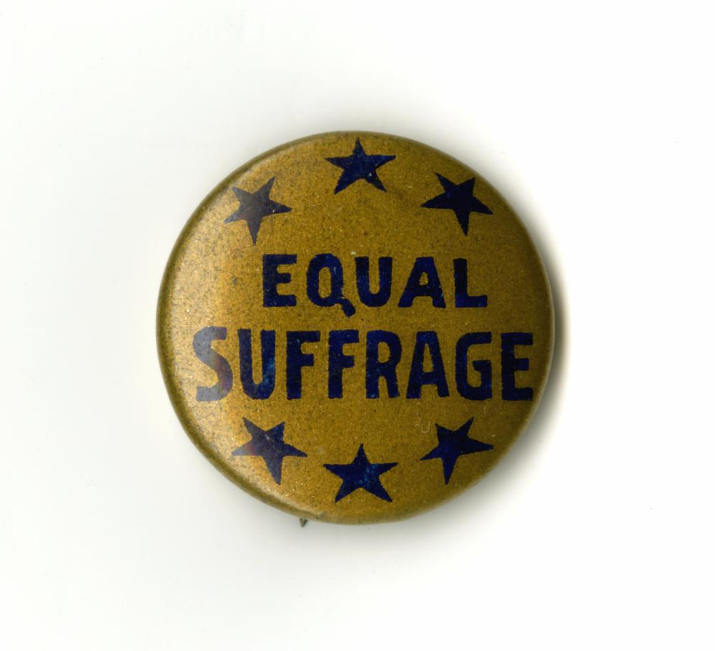

Left: “Votes for Women” was one of the most popular and recognizable slogans used by members of the woman’s suffrage movement.

Right: Button worn by supporters of equal suffrage. The six stars represent the first six states to grant full suffrage: Wyoming (1869), Colorado (1893), Utah (1896), Idaho (1896), Washington (1910), and California (1911).

Descriptions and Images Courtesy of National Museum of American History.

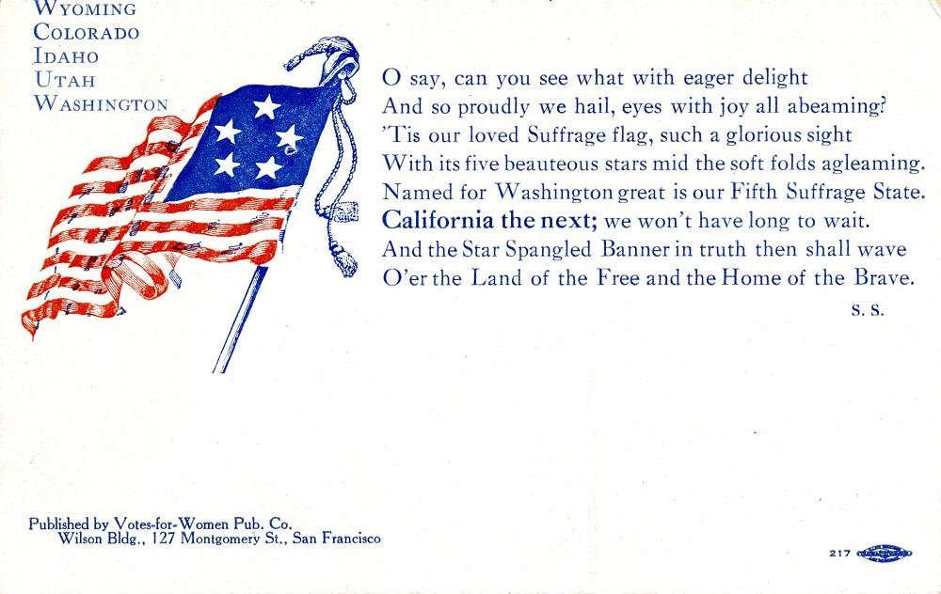

To the tune of the "Star Spangled Banner", this postcard celebrates the first five states to grant full suffrage: Wyoming (1869), Colorado (1893), Utah (1896), Idaho (1896), and Washington (1910). At the same time it looks forward to a coming (successful) vote in California. California granted women suffrage in 1911.

Description and Image Courtesy of National Museum of American History.

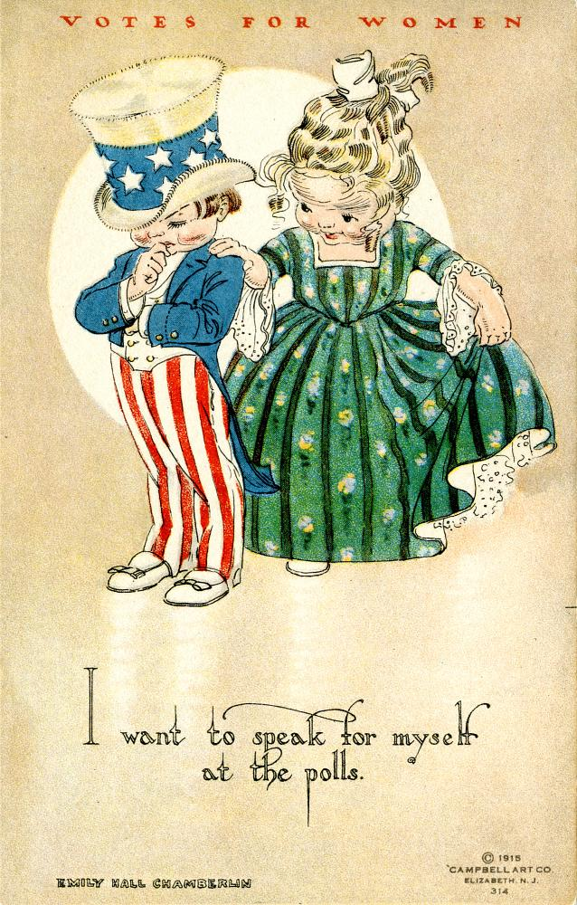

Some postcards used images of children to project a non-threatening image of women voters.
The National American Woman Suffrage Association began a postcard campaign in 1910, partly to raise awareness of the cause and partly as a fundraiser. The cards could be funny, serious, or sentimental. Some employed powerful patriotic symbols and logical arguments to make their case for woman’s right to vote.
Description and image courtesy of National Museum of American History.

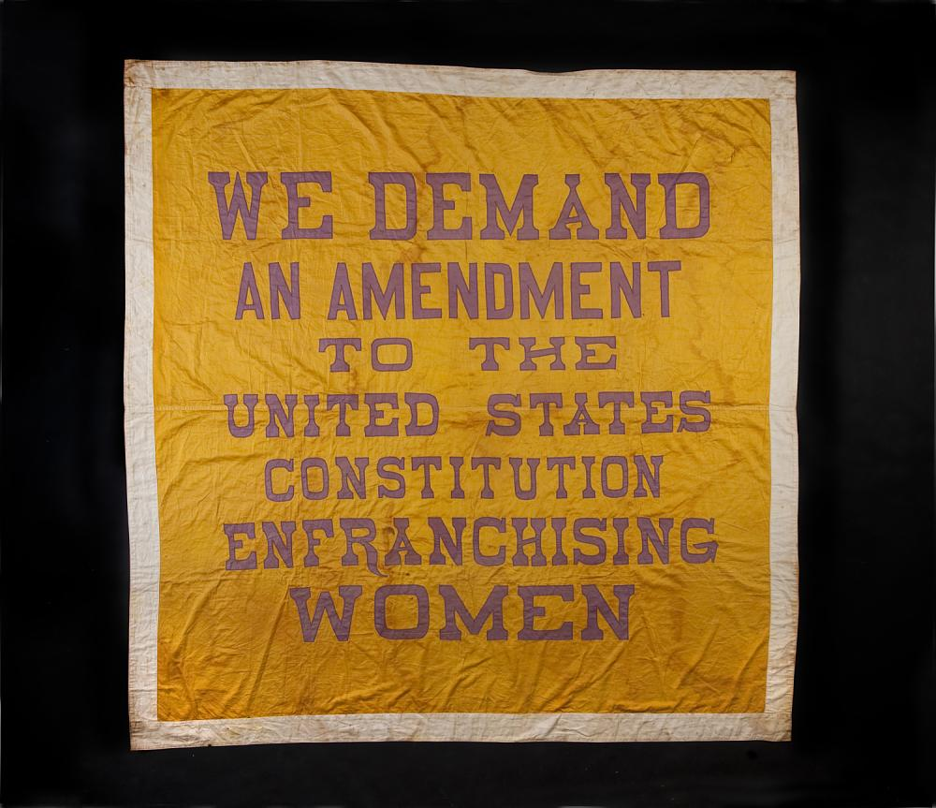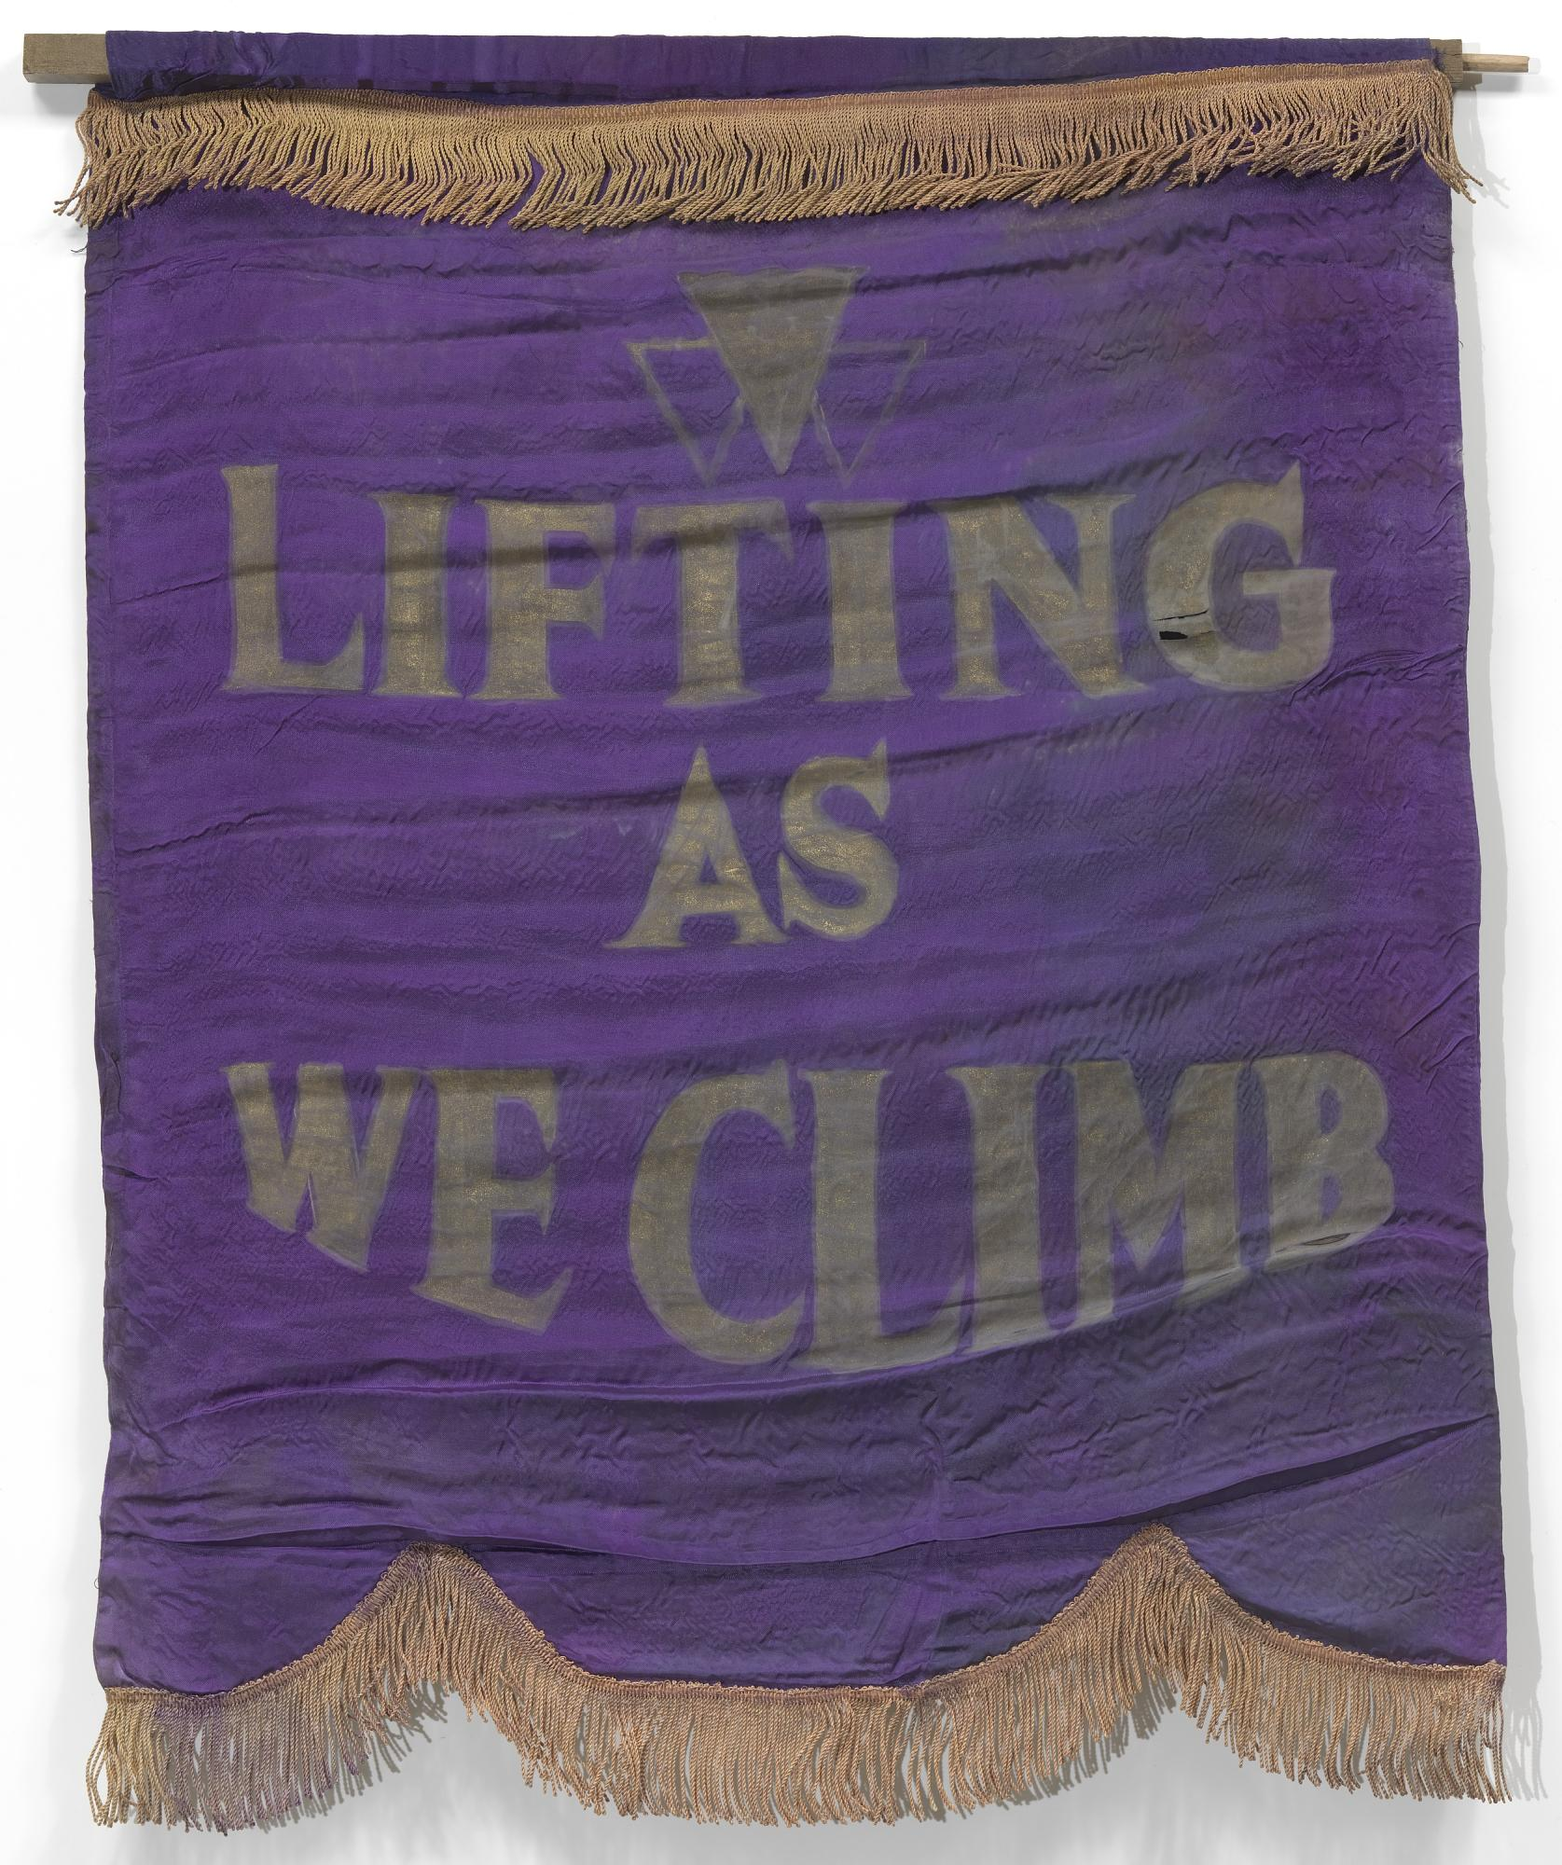

Left: Suffragists from the National Woman’s Party made smaller versions of the banner used on the 1913 parade’s first float. These "Great Demand" banners were used in demonstrations and rallies and at suffrage headquarters. Marie Gilmer Louthan carried this one in suffrage parades. You can see a version of this banner in the photo of Utah suffragists with Senator Smoot.
Description and image courtesy of National Museum of American History.

Right: This 1910 banner for the Oklahoma chapter of the National Association of Colored Women’s Clubs (NACWC) displayed the motto, “Lifting As We Climb,” and used the purple and gold colors of the suffrage movement. This organization advocated for the advancement (“lifting”) of African-Americans as well as for the rights of all women and children. Because the National American Woman Suffrage Association largely excluded black women, black suffragists fought for women’s suffrage and other rights through the NACWC.
Image courtesy of the National Museum of African American History and Culture.

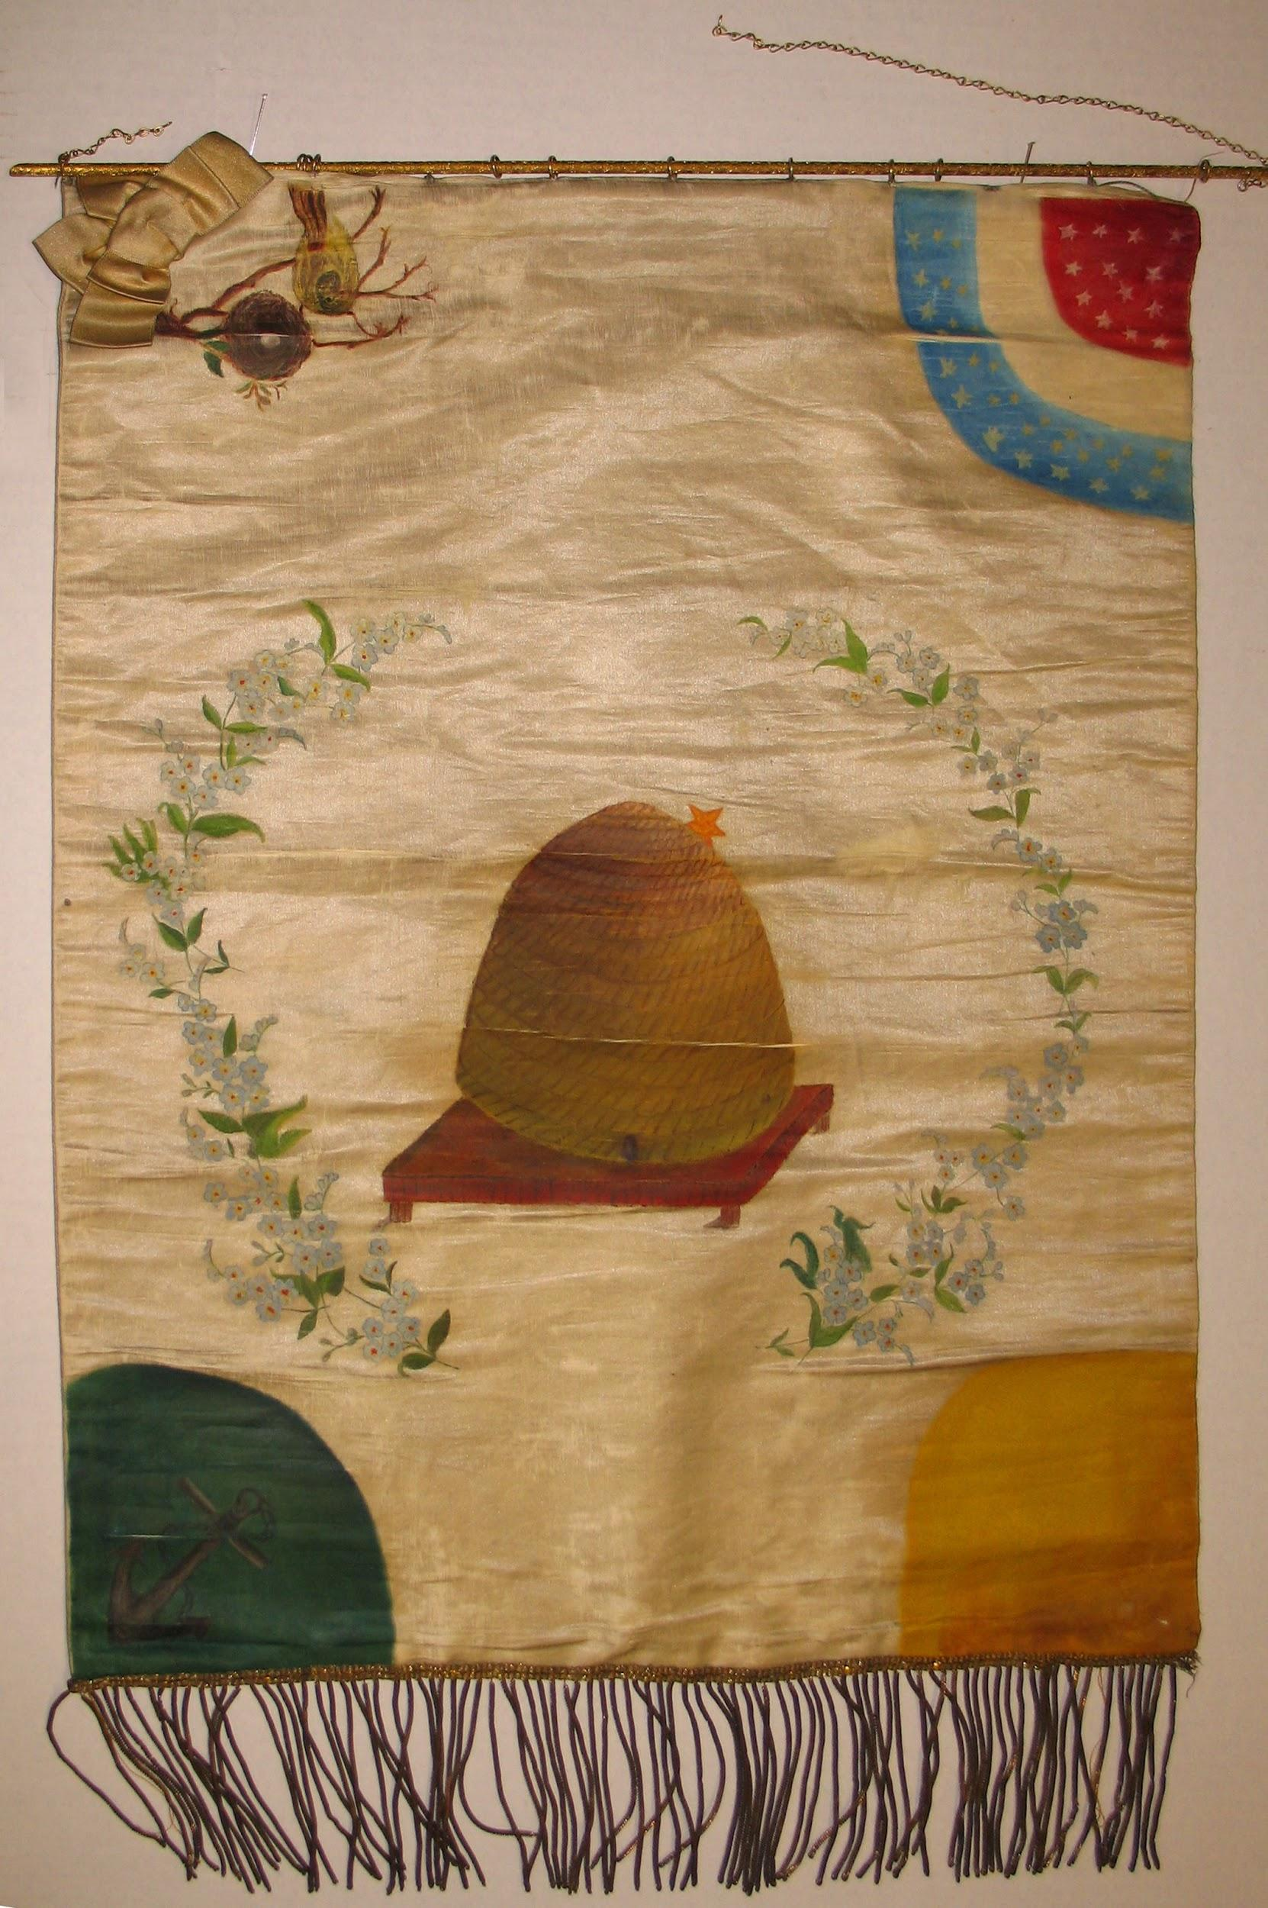

Woman Suffrage Association banner, 1893: This banner was used by the Woman Suffrage Association of Utah. Courtesy of International Society Daughters of the Utah Pioneers.

This speech was given by Susan B. Anthony, one of the most prominent national suffrage leaders, after she was arrested and fined $100 for casting a vote in the presidential election of 1872. Her vote was illegal because women did not have the right to vote at that time. She argued that as a citizen of the United States, the Constitution protected her rights and that women should not be disfranchised.
__________________________________________________________________________

Excerpts from

“IS IT A CRIME FOR A U.S. CITIZEN TO VOTE?”
By Susan B. Anthony
April 3, 1873

Friends and Fellow-citizens: I stand before you tonight, under indictment for the alleged crime of having voted at the last Presidential election, without having a lawful right to vote. It shall be my work this evening to prove to you that in thus voting, I not only committed no crime, but, instead, simply exercised my citizen’s right, guaranteed to me and all United States citizens by the National Constitution, beyond the power of any State to deny…

It was we, the people, not we, the white male citizens, nor yet we, the male citizens; but we, the whole people, who formed this Union. And we formed it, not to give the blessings of liberty, but to secure them; not to the half of ourselves and the half of our posterity, but to the whole people—women as well as men. And it is downright mockery to talk to women of their enjoyment of the blessings of liberty while they are denied the use of the only means of securing them provided by this democratic-republican government—the ballot.”

