Sarah Forten Purvis came from one of the most prominent free black families in pre-Civil War Philadelphia. The Forten family was active in abolitionism and the Underground Railroad. Sarah’s poems were widely distributed and numerous poems and articles appeared in The Liberator, the abolitionist and women’s rights newspaper founded by William Lloyd Garrison. Sarah and her sisters were founding members of the Philadelphia Female Anti-Slavery Society and played a significant role in the early abolition and suffrage movements in the 1830s.
Sarah Forten Purvis’ Poem The Slave Girl’s Address to Her Mother
Oh! Mother, weep not, though our lot be hard,
And we are helpless--God will be our guard:
For He our heavenly guardian doth not sleep;
He watches o’er us--mother, do not weep.
And grieve not for that dear loved home no more;
Our sufferings and our wrongs, ah! Why deplore?
For though we feel the stern oppressor’s rod,
Yet he must yield as well as we, to God.
Torn from our home, our kindred and our friends,
And in a stranger’s land, our days to end,
No heart feels for the poor, the bleeding slave;
No arm is stretched to rescue and to save.
Oh! Ye who boast of Freedom’s sacred claims,
Do ye not blush to see our galling chains;
To hear that sound word-- ‘that all are free’
When thousands groan in hopeless slavery?
Upon your land it is a cruel stain
Freedom, what are thou?--nothing but a name.
No more, no more! Oh God, this cannot be;
Thou to thy children’s aid wilt surely flee:
In thine own time deliverance thou wilt give,
And bid us rise from slavery, and live.

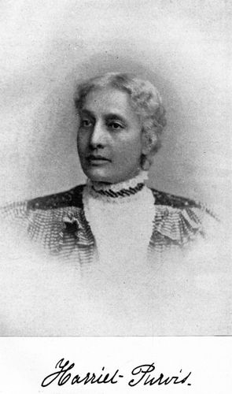
There is no known photo of Sarah Purvis. However, this is a photo of her sister, Harriet Purvis. Courtesy of Library of Congress.

