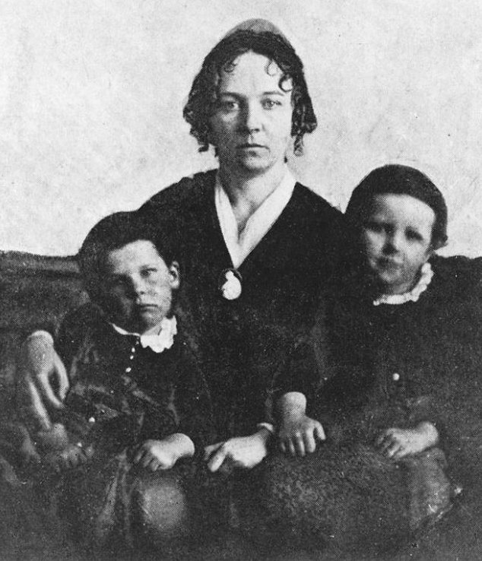
This speech was given by Elizabeth Cady Stanton to the American Anti-Slavery Society just before the Civil War. Stanton and many other suffrage leaders began their political activism in the abolition movement as they advocated for humanity and freedom and called for the emancipation of slaves as well as women. In her speech, Stanton contrasted the privileges of white men with the subjugation of both women and African-Americans argued that freedom for slaves would be a step closer to freedom for all.

Excerpts from “Speech to the Anniversary of the American Anti-Slavery Society, May 8, 1860
By Elizabeth Cady Stanton

It was thought a small matter to kidnap a black man in Africa, and set him to work in the rice swamps of Georgia; but when we look at the panorama of horrors that followed that event, at all the statute laws that were enacted to make that act legal, at the perversion of man’s moral sense and innate love of justice in being compelled to defend such laws; when we consider the long, hard tussle we have witnessed here for near a century between the spirit of Liberty and Slavery, we may, in some measure, appreciate the magnitude of the wrong done to that one, lone, friendless negro, who, under the cover of darkness and the star-spangled banner, was stolen from his African hut and lodged in the hold of the American slaver. That one act has, in its consequences, convulsed this Union. It has corrupted our churches, our politics, our press; laid violent hands on Northern freemen at their own firesides; it has gagged our statesmen, and stricken our Northern Senators dumb in their seats; yes, beneath the flag of freedom, Liberty has crouched in fear…

Eloquently and earnestly as noble men have denounced slavery on this platform, they have been able to take only an objective view. They can describe the general features of that infernal system – the horrors of the African slave trade, the agonizing sufferings of the middle-passage, and auction-block, the slave-pen and coffle, the diabolism of the internal traffic, the cruel severing of family ties, the hopeless degradation of woman; all that is outward they can see; but a privileged class can never conceive the feelings of those who are born to contempt, to inferiority, to degradation. Herein is woman more fully identified with the slave than man can possibly be, for she can take the subjective view. She early learns the misfortune of being born an heir to the crown of thorns, to martyrdom, to womanhood. For a while the man is born to do whatever he can, for the woman and the negro there is no such privilege. There is a Procrustean bedstead ever ready for them, body and soul, and all mankind stand on the alert to restrain their impulses, check their aspirations, fetter their limbs, lest, in their freedom and strength, in their full development, they should take an even platform with proud man himself. To you, white man, the world throws wide her gates; the way is cleat to wealth, to fame, to glory, to renown; the high place of independence and honor and trust are yours; all your efforts are praised and encouraged; all your successes are welcomed with loud hurrahs and cheers; but the black man and the woman are born to shame...

