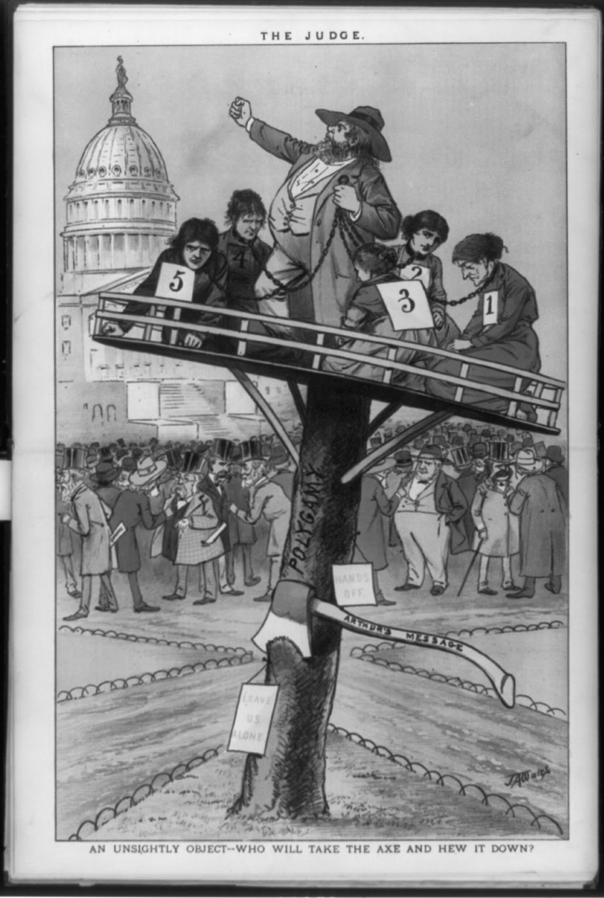
“An Unsightly Object,” The Judge, 1882
This cartoon bears the caption: “An Unsightly Object—Who Will Take an Axe and Hew It Down?” It portrays a Mormon man defiantly shaking his fist at Congress while standing on a platform labeled “Polygamy.” The man, shown as audacious and threatening, along with the signs labeled “Leave Us Alone” and “Hands Off,” are designed to be a depiction of the Mormon population as openly disobedient to governmental authority. He holds in his other hand chains that extend around the necks of five women who kneel around him. The women are portrayed as haggard, downtrodden, oppressed victims. They wear tags with numbers as if they are slaves to be sold. The scene is reminiscent of a slave auction, catering to the prevalent public attitude that polygamy was a form of mental and physical enslavement of women.
After the abolition of slavery in the South, many Americans turned their efforts to the prohibition of polygamy in Utah, which they saw as subjugating women and as challenging governmental authority. United States President Chester Arthur responded to these concerns by condemning polygamy in each of his State of the Union addresses and calling upon Congress for more radical legislation. The cartoon depicts indecisive congressmen surrounding the “Unsightly Object” of the polygamy platform. The axe portrayed in the cartoon, wedged into the platform-bearing pole, is labeled “Arthur’s Message” to indicate the cartoonist’s support of President Arthur’s stand against polygamy. Not long after, President Arthur signed the Edmunds Anti-Polygamy Bill into law, which made polygamy a felony and prohibited polygamists from voting, holding public office, and serving on juries.

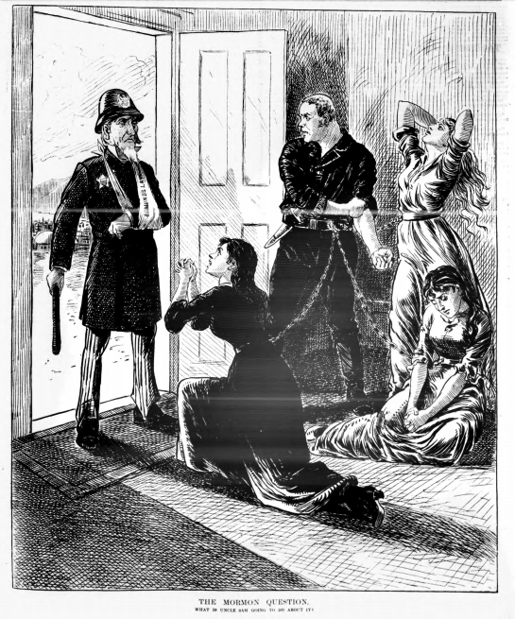
“The Mormon Question,” Daily Graphic, 1883
This political cartoon similarly contains commentary on the 1882 Edmunds Anti-Polygamy Act. It depicts Uncle Sam in police uniform, wearing a sling with the label “Edmunds Law,” implying that the United States was in fact weakened, rather than strengthened, by the 1882 legislation. Uncle Sam stands at an open door, facing an armed Mormon man chained to three enslaved wives. The man is rolling up his sleeve and making a fist, threatening to strike Uncle Sam who has one of his hands tied. The three wives are portrayed as despairing, pleading for help, or too downtrodden to resist enslavement. The caption reads: “The Mormon Question: What is Uncle Sam Going to Do About It?” The cartoonist challenges Congress to go further than the Edmunds Act to combat the Mormon threat. It portrays suspicions that Mormons, like the Confederacy, were attempting to form their own sovereign country in the Mountain West to protect a way of life repugnant to the rest of the nation. Like other anti-Mormon propaganda of its time, this cartoon uses imagery of slavery, violence, and defiance against the nation to resonate with the deep fears of another insurrection in post-Civil War America.

