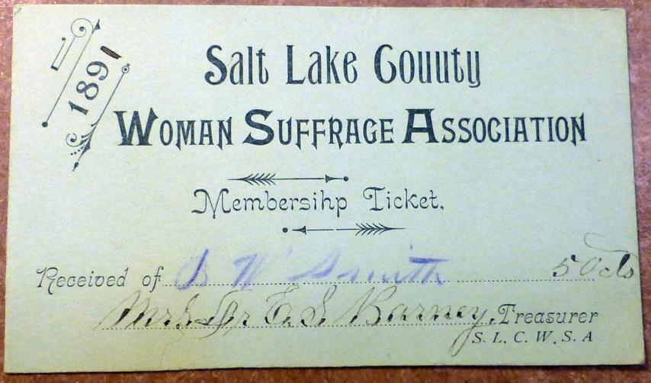
Bathsheba W. Smith’s membership ticket to the Salt Lake County Woman Suffrage Association, 1891. Courtesy of the LDS Church History Library.

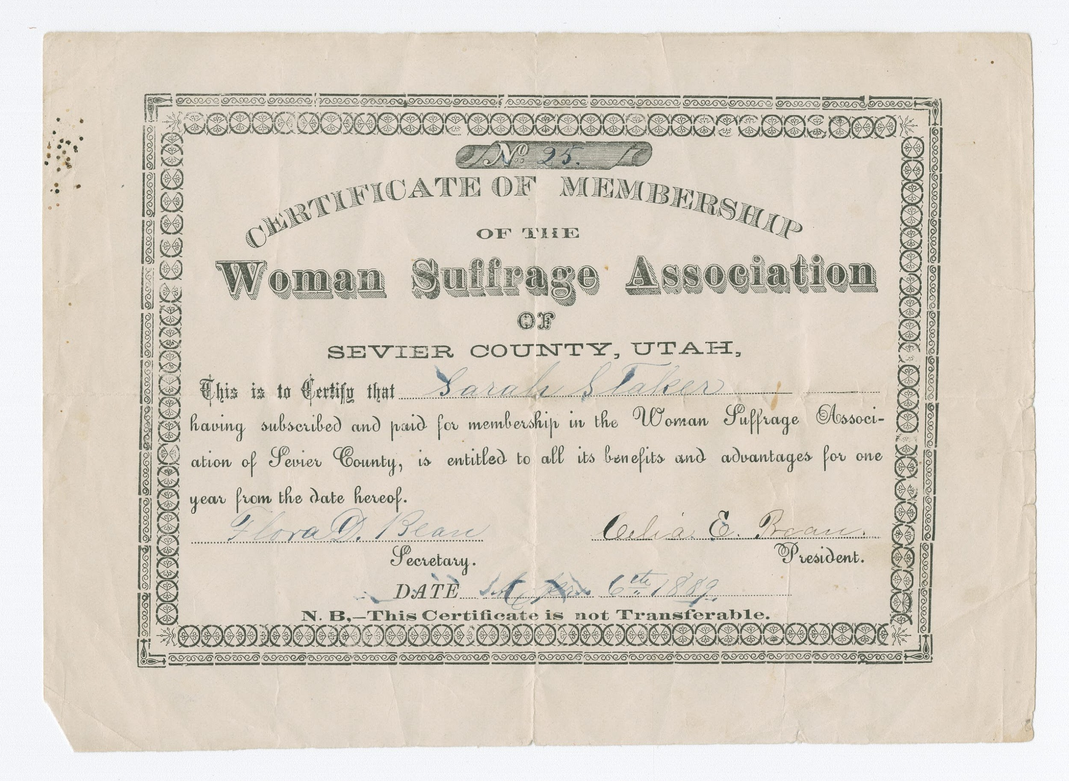
Sarah Staker’s certificate of membership in the Woman Suffrage Association of Sevier County, 1889. Courtesy of LDS Church History Library.

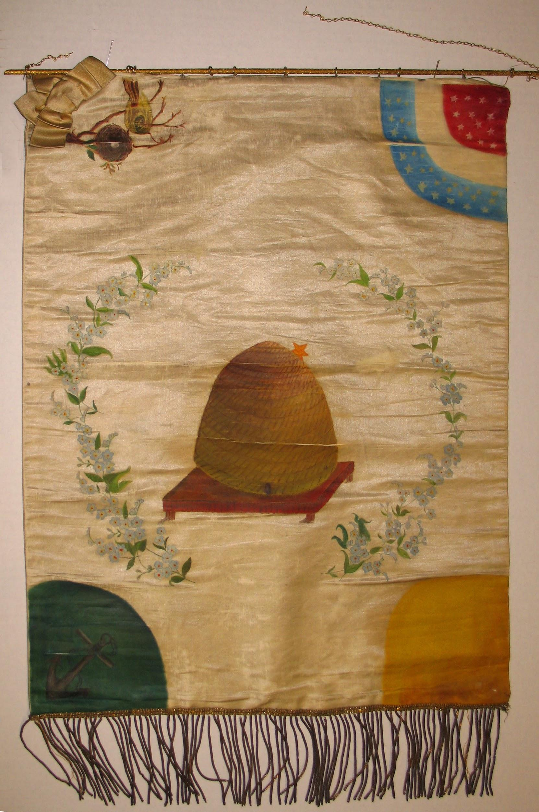
Banner for Utah Woman Suffrage Association, 1893. Courtesy of International Society Daughters of Utah Pioneers.

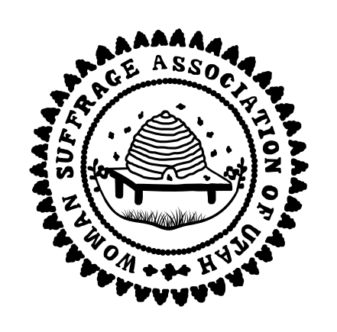
This stamp maker was used to stamp official documents and correspondence for the Woman Suffrage Association of Utah. Courtesy of the LDS Church History Museum.

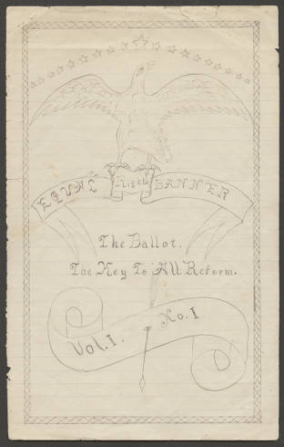
The cover of the first issue of the handwritten newsletter of the Beaver County Woman’s Suffrage Association. It contains the subtitle: “The Ballot--The Key to All Reform.” Courtesy of BYU Special Collections.
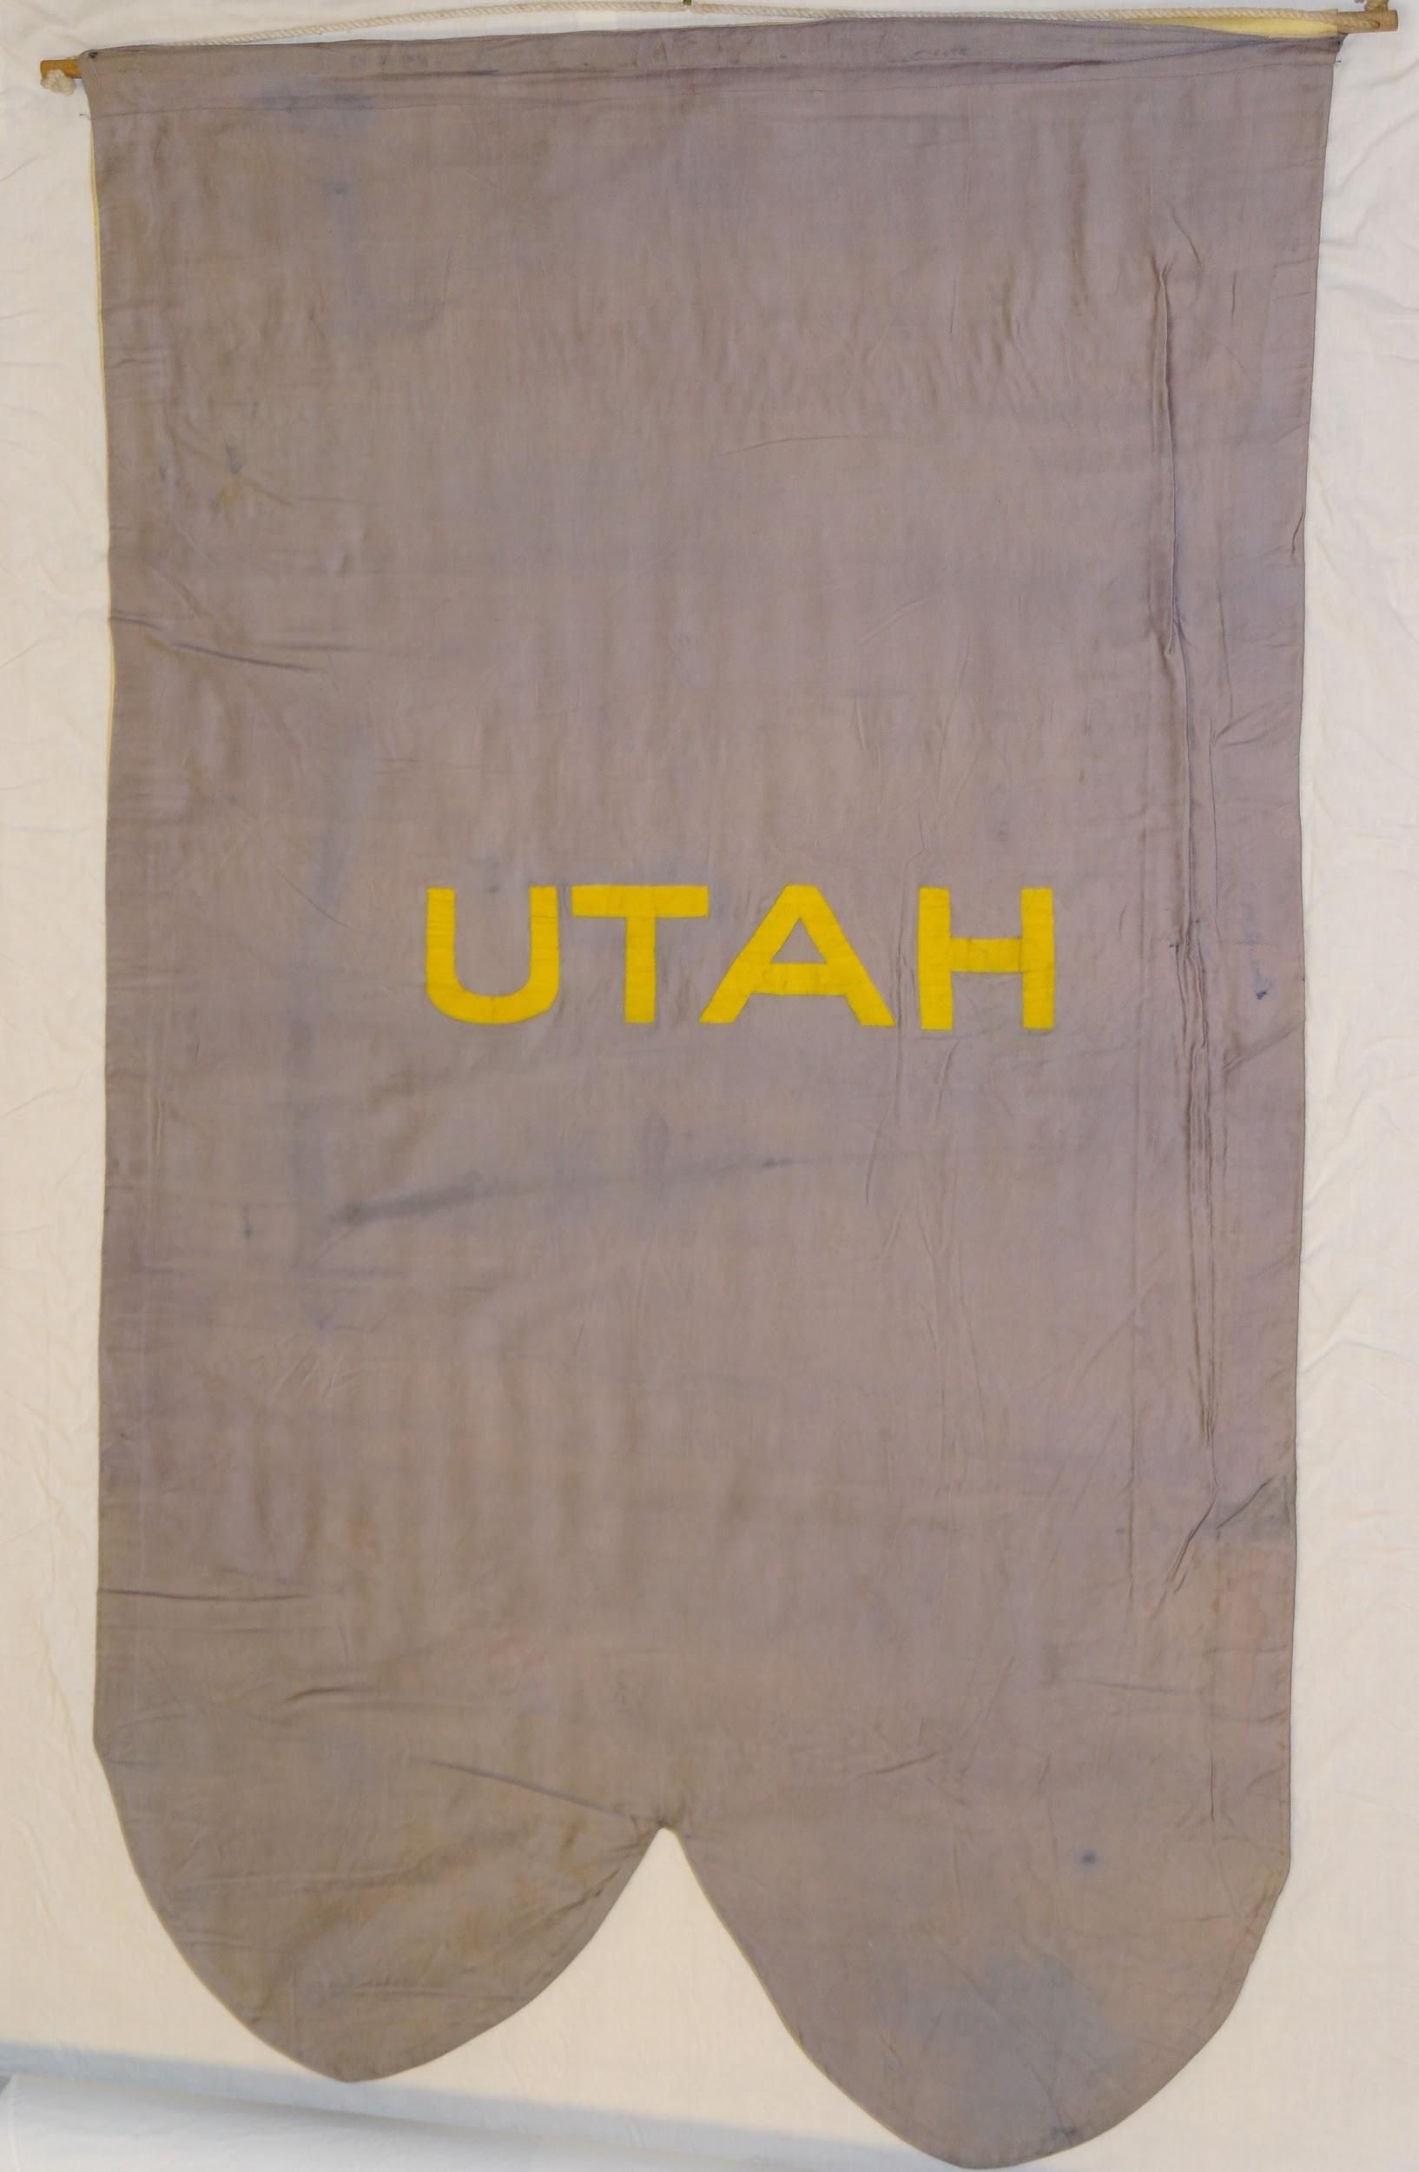
Utah state banner, 1913. Courtesy of the National Woman’s Party.

