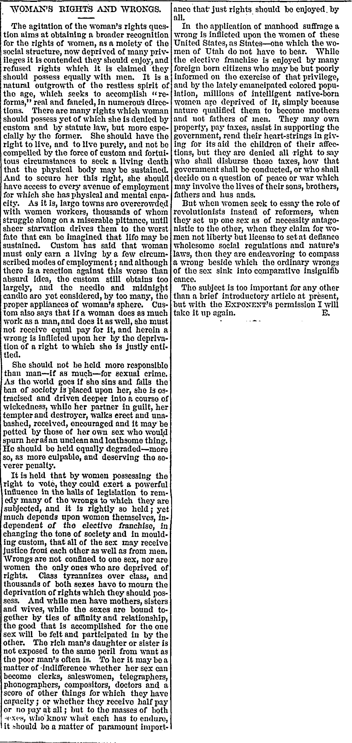
From Woman’s Exponent, Vol. 1 (June 1872), No. 1

WOMAN’S RIGHTS AND WRONGS.

The agitation of the woman’s rights question aims at obtaining a broader recognition for the rights of women, as a moiety of the social structure, now deprived of many privileges it is contended they should enjoy, and refused rights which it is claimed they should possess equally with men. It is a natural outgrowth of the restless spirit of the age, which seeks to accomplish “reforms,” real and fancied, in numerous directions. There are many rights which woman should possess yet of which she is denied by custom and by statute law, but more especially by the former. She should have the right to live, and to live purely, and not be compelled by the force of custom and fortuitous circumstances to seek a living death that the physical body may be sustained. And to secure her this right, she should have access to every avenue of employment which she has physical and mental capacity. As it is, large towns are overcrowded with women workers, thousands of whom struggle along on a miserable pittance, until sheer starvation drives them to the worst fate that can be imaged that life may be sustained. Custom has said that woman must only earn a living by a few circumscribed modes of employment; and although there is a reaction against this worse than absurd idea, the custom still obtain too largely, and the needle and midnight candle are yet considered, by too many, the proper appliances of woman’s sphere. Custom also says that if a woman does as much work as a man, and does it well, she must not receive equal pay for it, and herein a wrong is inflicted upon her by the deprivation of a right to which she is justly entitled...

It is held that by women possessing the right to vote, they could exert a powerful influence in the halls of legislation to remedy many of the wrongs to which they are subjected, and it is rightly so held; yet much depends upon women themselves, independent of the elective franchise, in changing the tone of society and in moulding custom, that all of the sex may receive justice from each other as well as from men. Wrongs are not confined to one sex, nor are women the only ones who are deprived of rights. Class tyrannizes over class, and thousands of both sexes have to mourn the deprivation of rights which they should possess. And while men have mothers, sisters, and wives, while the sexes are bound together by ties of affinity and relationship, the good that is accomplished for the one sex will be felt and participated in by the other. The rich man’s daughter or sister is not exposed to the same peril from want as the poor man’s often is. To her it may be a matter of indifference whether her sex can become clerks, saleswomen, doctors, and a score of other things for which they have capacity; or whether they receive half pay or no pay at all; but to the masses of both sexes, who know what each has to endure, it should be a matter of paramount importance that just rights should be enjoyed by all.

In the application of manhood suffrage a wrong is inflicted upon the women of these United States, as States--one which the women of Utah do not have to bear. While the elective franchise is enjoyed by many foreign born citizens who may be but poorly informed on the exercise of that privilege, and by the lately emancipated colored population, millions of intelligent native-born women are deprived of it, simply because nature qualified them to become mothers and not fathers of men. They may own property, pay taxes, assist in supporting the government, rend their heart-strings in giving for its aid the children of their affections, but they are denied all right to say who shall disburse those taxes, how that government shall be conducted, or who shall decide on a question of peace or war which may involve the lives of their sons, brothers, fathers and husbands.

But when women seek to essay the role of revolutionists instead of reformers, when they set up one sex as of necessity antagonistic to the other, when they claim for women not liberty but license to set at defiance wholesome social regulations and nature’s laws, then they are endeavoring to compass a wrong beside which the ordinary wrongs of the sex sink into comparative insignificance.

The subject is too important for any other than a brief introductory article at present, but with the EXPONENT’S permission I will take it up again. E.

